LIONEL  LIONEL.258593@2freemail.com  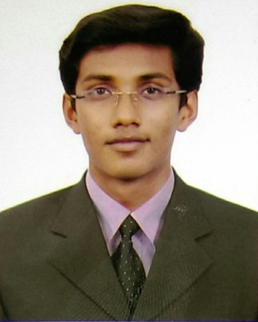  Personal Data:  DOB : 07June 1993  Gender: Male  Nationality :India  Visa status :Visit visa  (Valid till 24th April 2016)  Languages Known:  English, Hindi, Kannada, Konkani (Read, Write and Speak) | Career Objective:  To work in competitive environment in a challenging position and be an integral part of growth orientated team with a clear path wherein I wish to consolidate my intelligence, hard work and dedication to contribute to the organisation’s profitability. Believe strongly in teamwork, sense of urgency, continuous improvements and honesty of purpose resulting in customer focus.  Professional Qualification:  Degree: Bachelor of Engineering  Stream: Mechanical Engineering  Institute: Sahyadri College of Engineering and Management,Mangalore  University: Visveswaraya Technological University (VTU),Belagavi  Batch: 2011-15  B.E Aggregate: 65.30%  Academic Record:  Courses Board/University Aggregate Grade Offered  B.E VTU 65.30% First class  PUC Karnataka Board 74.66% First class  SSLC Karnataka Board 75.52% First class  Working Experience:15th July 15 to 20th Jan 16  Arvind Motors Pvt Ltd (Authorised dealer - Tata Commercial Vehicles)  Designation: Floor supervisor  Responsibility:  - Responsible for opening job card, allocation of job and monitoring work in progress / ancillary repairs.  - Interacting with the customers to understand their requirements related to the vehicle and assure the best quality of work.  - Control complete repair /service work by following up with spare parts division, ancillary supplier outsourcing authority, man power resource etc.  - Update the estimation and status of repair jobs to the customer through written reports or telephone.  - Warranty handling process and reworking debited and rejected claims.  - Briefing on the process of job card completion.  - Preparing service invoices as per the cost sheet.  - To achieve the team target on a regular basis.  - Provide efficient solutions to the development of processes.  - Effective use of time and resources available.
Certified courses:
- Has acquired the best of theoretical and practical knowledge in Diesel Engine Management, Gasoline Engine Management and Vehicle Diagnosis in ‘BOSCH LIMITED’ at Bangalore.
- Training in ‘Automotive Mechanical, Electrical & Electronics in ‘Mandovi Motors’- Maruti Suzuki at Mangalore
- Has undergone Industrial training in “Kudremukh Iron Ore Company Limited (KIOCL), Pellet Plant unit’’ at Mangalore.

Technical skills:
- Working knowledge in CAD software’s - Solid Edge v20.
- Working knowledge in CAM software – CNC with NC-turning and NC-milling
- Working knowledge in CAE software - FEMAP with Nastran
- Excellent in MS Office 2010 (MS Word, MS Excel, MS power point)

Strengths:
- Flexible, energetic, patient and able to work under extreme pressure and multi-cultural team environment.
- To manage multiple priorities efficiently and expeditiously to exercise professional judgment and discretion.
- Willing to accept new dynamic challenges in my assigned task.
- Ability to establish and maintain effective working relationships with associates.

Activities:
- Secured First place in Contraption competition which was held in our college on the occasion of Eximius-2.0
- Secured second place for Compressed Air Vehicle Project Competition which was held in our college on the occasion of Tech Vision 2014

Project work carried out during the period of study:
- Project title:“Compressed Air Vehicle”
I have carried out this project to overcome the main disadvantages of fossil fuel based vehicles which results in carbon emission or pollution. This vehicle uses compressed Air as its fuel for its working.
- Project title: “Multipurpose machine for making Jackfruit Products”
I have carried out this project as part of academic syllabus. This project aims to produce good quality food products of Jackfruit at short time and at feasible cost.
- Project title: “Black Board Cleaner”
As part of this project we designed and developed an inventive device which operates based on four bar link mechanism
Declaration
I hereby declare that the above mentioned information is true up to the best of my knowledge.

