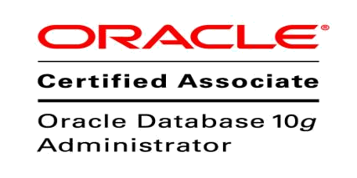
Mohamed
Mohamed.258599@2freemail.com

System Administrator

Qualification Highlights:

Professional IT administrator of systems offering two years and eight months
Experience with the following core functions:

- Writing SQL-Queries on SQL-Servers, Oracle and MS-Access Databases.

- Creating Crystal Reports on SQL-Servers and MS-Access Databases.

- Monitored the LAN/WAN network environment including routers, switches, firewalls, Internet access and software applications.

- Installation, configuration and maintenance of windows servers, system network components.

- Performed troubleshooting and diagnosis to hardware/software network failures, and provided resolutions.

- Creating Auto Backup on SQL-Servers, Oracle and MS-Access Databases.

Technology Summary:

Hardware | : | Assembling switches, routers and networking
Operating Systems | : | Windows Platform, Linux OS
Software | : | SQL Server, Oracle Server , MS Office
Database Operations | : | Installing, upgrading and migration of Oracle database,
 |  | Backup and Recovery, Restore
Database Tools | : | RMAN, EXP, IMP, Data Pump (EXPDP , IMPDP),OEM,
 |  | AWR, ADDM, Flash Back Recovery.
Core Competencies:

- Problem solving: Analytical and decision making skills.
- Team-worker: Ability to guide and work with others.
- Quick Learner & Sincere.
- Ability to perform in any stress related situation.
- Commitment to any work assigned.

Professional Experience:

System Administrator at Prime InfoTech LLC, Dubai from October 2014 to till Present

Installation and Optimization:

- Installed, optimized and configured new servers and application upgrades in existing network environment as per requirements.

- Installed and configured secured environments, VPN Internet connectivity of virtualized server environment and clients.

Technical Support and Administration:

- Managed and administered Windows/Linux systems – Performed periodic maintenance, provided technical support and executed systems engineering.
- Maintained MS Exchange Server – Performed troubleshooting and provided resolutions for server problems.
- Implemented proper recovery procedures for disasters and administered user- accounts’ mailbox.
- Maintained the timely back-up of important data and management resources.
- Assisted in the timely recovery of data lost due to software crash or hardware failure.
- Conducted periodic performance tests on existing servers.

Educational Qualifications:

- Master of Computer Applications under Anna University – Chennai in Tamil Nadu, India on 2013.
- Bachelor of Computer Applications under Periyar University – Salem in Tamil Nadu, India on 2010.

Certification:
  - Oracle Certified Associate(OCA) in Oracle 10g.

Visa Status:
  - Employment Visa /Transferable.

Reference:
  - References are available on request.

Personal Information:

Date Of Birth | : | 21-06-1989
Nationality | : | Indian
Marital Status | : | Single
Sex | : | Male

D e c l a r a t i o n

I hereby declare that all the information given above is true to the best of my knowledge and belief. Given an opportunity, I shall do the job to the satisfaction of my superiors.

