Whats app Mobile:+971504753686
Gulfjobseeker.com CV No:259649
E-mail: gulfjobseeker@gmail.com

Purchasing / Senior Buyer
Procurement ~ Supply Chain Management ~ Material Management

A dedicated analyst, proficient in running successful method-oriented operations & taking initiatives for business excellence through process improvement

Seeking challenging assignments in Procurement / Supply Chain Management / Material Management.

PROFILE SUMMARY

- A dynamic professional with 4.5 years of experience in:
Procurement Supply Chain Management Material Management
Vendor Development Project Management Team Management
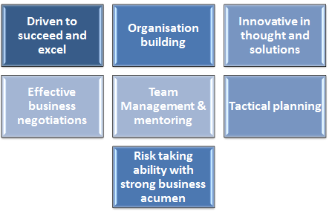
- Expertise in identifying & developing potential vendors locally & globally for the right sourcing, achieving cost effective purchases of raw materials
- Adept in checking project stocked material and ensuring the timely execution of project completion.
- Skilled in material resource planning and sourcing of local and international material for procurement of various stocks to maintain smooth flow.
- Proficient in handling Material Management activities involving material planning, techno-commercial negotiations, scheduling and procurement of components, raw materials from various sources
- Resourceful in formulating the sourcing plans / strategies and vendor identification according to the categories / development with focus on strengthening effectiveness
- A result – oriented individual with excellent analytical, negotiation & interpersonal skills
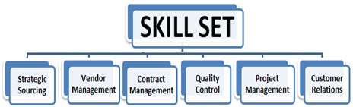
CORE COMPETENCIES
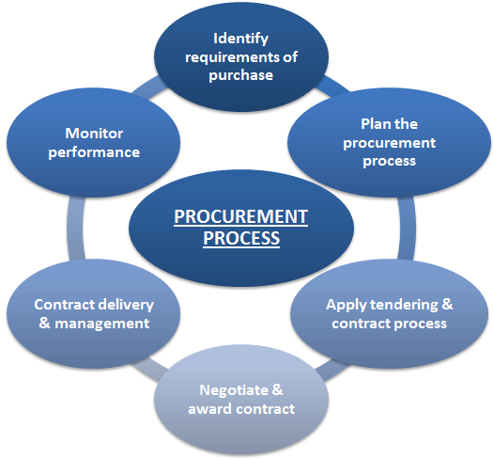
Supply Chain Management
- Ensuring availability and delivery of right quality materials at right time, price & terms; devising efficient logistics management system to ensure delivery of the goods / shipments as per committed timelines and cost
- Managing supply chain for distributing goods in warehouse to the manufacturing unit for achievement of targets within specified parameters

Materials / Inventory Management
- Monitoring purchase, receipt, inspection, storage, inventory and distribution of stock commodities; ensuring proper storage facilities for various components as per supplier recommendations
- Keeping close track of non-moving items & slow - moving items and providing details of the same to the management every month in order to avoid dead inventory that ultimately effects the project budget

Procurement
- Efficiently identifying and developing potential vendors locally for the right sourcing, achieving cost effective purchases of Raw Materials; implementing systems for enhancing operational efficiency
- Designing strategies for indigenizing products thus saving cost and revenue for the company; planning, organizing and controlling all requisite activities to perform such as techno – commercial evaluation, negotiation, recommendation, ordering, inspection, expediting & tracking, reporting, logistic and delivery, payment processing, etc.
- Invoices reconciliation, submission of invoices to Finance and tracking for timely payment

Vendor Development
- Assessing the performance of the vendors based on various criterions such as percentage for rejections, quality improvement rate, timely delivery, credit terms, etc.; overseeing follow-up with vendors for engineering & timely deliveries, quality checks & ensuring timely payments
- Monitoring incoming materials supplied by vendors and ensuring they are as per quality & quantity specifications; assisting vendors in the production processes / systems and providing them suggestions for improving process efficiency

ORGANIZATIONAL EXPERIENCE

Since Feb’15 **Consulting International Company

U.A.E. as Consultant (Marketing and Immigration)

Role:

- Liaising and networking with a range of stakeholders including customers, colleagues, suppliers and partner organizations
- Communicating with target audiences and managing customer relationships
- Sourcing advertising opportunities and placing adverts at various media
- Managing the production of marketing materials, including leaflets, posters, flyers, newsletters, and e-newsletters
- Arranging the effective distribution of marketing materials
- Maintaining and updating customer databases
- Organizing and attending events such as conferences, seminars, receptions and exhibitions
- Contributing to, and developing, marketing plans and strategies
- Managing budgets and evaluating marketing campaigns

Dec’10 – Dec’14 Aggarwal Sweets Pvt. Ltd

India as Purchase/Supply chain Manager

Role:
- Managed purchasing activities including procurement of services using informal, formal bids By Vantage & Mars Reduced company’s risk by using appropriate contracts to award work
- Received, examined and processed departmental requisitions
- Increased the quality of purchase orders by mentoring requistioners in providing greater detail of work to be awarded under PO
- Responsible for sourcing vendors for various maintenance, equipment, tools & supplies
- Reduced processing time of invoice issues by healthy and effective communicating with accounts payable department
- Maintained records in accordance with established policies, procedures and audit guidelines
- Involved in physical verification of fixed assets & inventory of Raw Material and finished goods

Highlight:
- Played a vital role in managing ongoing operations of Outsourced Projects, Setup new units & other daily routine work for Manufacturing, Utilities, Machines and Other requirements.
- Served as a key member for compiling and finalizing the complete Supply Chain Management Policies and procedures for year 2013- 2014

Apr’09 – Dec’10 Bikaner’s Pvt. Ltd

India as Purchase Executive / Officer
Role:

- Check validity of requests to purchase, obtaining any additional necessary paperwork and manage any non-compliance requests
- Act as liaison between the Senior Procurement and the Operational team
- Manage the GRN process to ensure prompt action and resolution in conjunction with the Procurement Systems Administrator
- Liaise with requesters/ departmental contacts to ensure timely resolution of queries
- Liaise with Accounts Payable to resolve supplier payment issues
- Handle complaints
- Provide status reports to the Operational Procurement Manager on an agreed basis

Highlights:
- Successfully completed small and multiples projects during high season demand like big concerts, Seminars etc.
- Holds the distinction of providing all sorts of assistance regarding Materials required or Material to be dispatched in order to ensure that material will be in time on cited project that will be helpful for smooth running and completion of Projects / Operations

COURSES ATTENDED

- Basic Export and Import course conducted by “FTDC“ Delhi in 2008
- IELTS conducted by “IDP, Australia” Delhi in 2014

TRAINING ATTENDED

- Retail and Wholesale business at Aggarwal Sweets Manufacturing and Retail supply chain in Delhi in July, 2014
- Marketing Strategies at Current Company, Dubai in March-April, 2015

Projects

- As a part time, Played a vital role in Purchasing and Supervising to construct a 4 story residential building in Vijay Vihar, Delhi in 2012-March, 2014
- As a part time, Played a vital role in Purchasing and Production of footwear in Footwear Industries in Mangol Puri Industrial area, Delhi in 2014- Jan, 2015

EDUCATION

B.Com. from Delhi University, India in 2010

Private Pilot License from Ahmedabad International Airport.

IELTS Test Score 6.5 Bands in 2014

KEY SKILLS

- Planning, Negotiation skills, Execution, Monitor and Control, Results focused, Financial, Technical Skills, Analytical Skills, Critical Thinking

IT SKILLS

- MS Office (Excel, Word, Project & Visio)
- Windows 2000 / XP /2007
- Designing /Editing on Paint

MEMBERSHIP

- International Sri Krishna Consciousness

PERSONAL DETAILS

Date of Birth: 08th June 1986

Languages Known: English, Hindi, Punjabi
Nationality Indian
Marital Status Married

