CURRICULUM VITAE
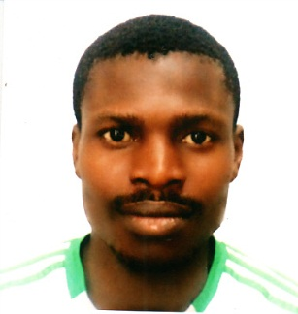
AKACHUKWU
AKACHUKWU.260352@2freemail.com
Security Guard

Career Objective:

I am a professional and qualified security with experience on the ground. A diligent and responsible worker, I work well in both static and mobile work modes. It is my hope to secure in-house employment with a well-established and respected security contractor.
Personal Data:

- Sex : Male
- Date of Birth : 16-12-1992
- Nationality : Nigeria
- Marital status : Single
- Visa Status : TouristVisa (Long Term)
- Language : English
Contact Address:
Experience:

- Worked a Security with SHERATON HOTEL, Nigeria for 2 Years.
- Worked as Security with DIAMOND BANK PLC, Nigeria for 2 Years.

Responsibilities:
- Pro-actively ensuring the protection of merchandise, property and assets.
- Creating a safe and comfortable working environment for employees and visitors.
- Directing emergency vehicles and other traffic if a major incident occurs.
- Responding to emergency situations as they arise.
- Accurately reporting all incidents to senior managers.
- Preventing and detecting offences on site.
- Conducting searches of personnel, vehicles and bags etc.
- Producing written reports.

Education:

- S.S.C.E (Secondary School certificate Examination)
- N.D (National Diploma in Petroleum Engineering)
Competencies:
- Good observation skills.
- Aware of health and safety issues.
- Dealing with people politely but in a authoritative manner.
- Capability to monitor information feeds simultaneously from multiple sources.
- Having a professional approach to all routine tasks.
- Ability to communicate effectively at all levels.
- Experience of working on major events.
Personal:
- Well groomed and confident.
- Having a professional attitude.
- Possessing a friendly, approachable personality.
- Smart and presentable appearance.
- Willing to work shifts, morning, nights etc.

Declaration:

I declare that the information given above is correct to the best of my knowledge. I’m looking forward to get an opportunity to work in your esteemed organization.

