Curriculum Vitae

Whats app Mobile:+971504753686
Gulfjobseeker.com CV No:1563816
E-mail: gulfjobseeker@gmail.com

POSITION DESIRED: Sales Executive
Personal Profile
Date of Birth : May 31st 1990
Civil Status : Married
Gender : Female
Language : English
Career Objective
Seeking a challenging position in an Organisation as a Receptionist, where I can utilize my skills and experience. Enhance customer satisfaction by adding value to the current services offered to customers.

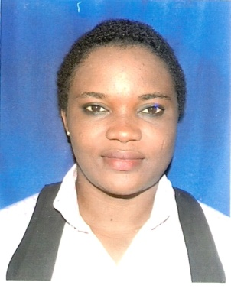
Professional Experience

Paper fig Restaurant 31 May 2014– November 2015
Position: Receptionist cum Runner
Job Responsibilities:
- Welcomes visitors by greeting them in person or on the phone
- Answering or referring inquiries.
- Taking and receiving customer orders on phone
- Maintains security by following procedures.
- Issuing visitor badges
- Monitoring logbook
- Giving instructions.

Acadia Hotel Pretoria South Africa
Position: Receptionist April 2011-february 2014
: Greeted, registered and assigned rooms to guests
: Processed guest check ins and outs
: Prepare and complete room and restaurant bills
: Answering telephone and in-person queries related to hotel services and resolve any issues
: Assisted guests in storing valuables in secure deposit box

Educational Background
- Completed Secondary School
COMPUTER SKILLS: Microsoft office
Skills and Strengths
- Excellent customer service skills and demonstrable experience
- Good interpersonal and communication skills
- Confident and Self motivated
- Be able to work individually or as a team with or without supervision
- Flexible and adapt to different working environment quickly
- Ability to work for long hours under pressure

