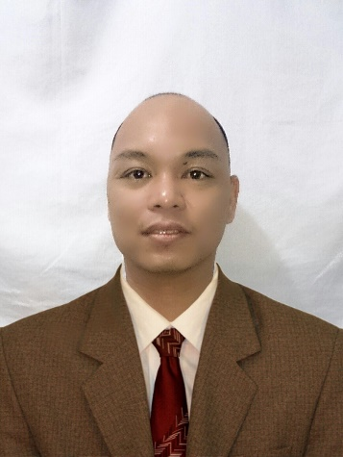
RODERICK NACPIL
Najda Street Al Markaziyah Abu Dhabi UAE
+971567749928
rodericknacpil@yahoo.com

Seeking for a challenging position that would enhance my knowledge and skills and vice versa to share my credentials, experiences and abilities and become an asset to the company.
Education
- March 1996 to March 1999 Third Year Level at Lyceum Northwestern University (Bachelor of Science in Electronics and Communications Engineering ) Dagupan City Philippines
Experience
- December 01, 2014 to Current
Messenger (IT Department) ADMA (OPCO) Abu Dhabi Marine Operating Company
Responsible in the installation of new pc's, printers and scanners according to the exact work station of the user information. Basic troubleshooting and clerical duties.
- August 01, 2013 to December 01, 2014
Office Boy at TAKREER (Abu Dhabi Oil Refining Company ) Headquarters
Prepares and serves tea coffee and other beverages for the office staffs and other guest. Responsible in attending the meeting room. Disseminating details through phone fax and email. Organizing and keeping files and handling projects. Answering and forwarding phone calls, and taking messages. Providing details to phone callers, and office visitors. Monitoring the use of devices and supplies within the workplace. Dealing with the inquiries or needs from the visitors and office staffs. Maintaining the cleanliness of the kitchen.
- December 25, 2012 to July 30, 2013
Office Boy at NCTH (National Corporation for Tourism and Hotels) Head Office
Abu Dhabi United Arab Emirates
- May 15, 2004 to February 25, 2009
Officer in Charge / Barista ( Figaro Coffee Company )
Manila Pavilion Hotel and Casino ( Ermita , Manila Philippines )
Consistent kept bar and work areas clean and sanitary in compliance with bar standards and local state and federal laws. Accurately and quickly calculated checks and changes made. Greeted newly seated guest in a friendly and timely manner. Maintained a positive working relationship with fellow staff and management. Confirmed accuracy of order against requisitions. Provide fast, friendly and professional service to all casino guest and beverage servers. Quickly remove debris accumulated at the bar to consistently maintain a clean service area. Prepared and serve delicious espresso and coffee drinks according to memorized standard recipes. Routinely thoroughly cleaned the coffee and espresso machines and other bar tools and machines . Accurately filled costumer orders. Promote positive costumer and associate relation through courtesy and professional service appearance. Maintain stock levels to prevent shortages of critical items. Suggestive upselling. Effectively handled costumer complains and special request.
- October 25. 2003 to March 25, 2004
Sales Assistant at Magic Mall ( School and Office supplies )
Urdaneta City, Philippines
Greeting costumers who enters the shop. Involve in stock control and management. Assisting shoppers to find the goods and products they are looking for. Stocking shelves with merchandise. Answering queries from the costumers. Reporting discrepancies and problems to the supervisor. Giving guidance and advice on product selection to costumers. Receiving and storing the delivery of large amount of stocks. Responsible dealing with costumer complains. Working within stablished guidelines particularly with brands. Keeping up to date with special promotions and putting up displays.
- July 1999 to March 2000
Kitchen and Service Crew at Mc Donalds ( CSI Mall Urdaneta City Philippines )
Greeting and welcoming of costumer as they enter the store premises. Took necessary steps to meet costumer needs and effectively resolve food or service issues. Record costumer orders and repeated them back in a clear and understandable manner. Communicate clearly and positively with co- workers and management. Opening the doors and saying thank you to the costumers after eating. Maintaining the high standard of food handling and safety to avoid contamination of the products. Always wears proper hygiene.

Personal details
Name : RODERICK NACPIL
Age : 37 Years old
Birthdate : 20 September 1979
Marital Status : Married
Nationality : Filipino
Religion : Christian
Languages : English , Filipino
Passport : EC3617140
Date of Issue : 09 March 2015
Date of Expiry : 08 March 2020
Place of Issue : Philippine Embassy Abu Dhabi UAE
Visa status : Employment Visa Company Sponsorship

