Email : faiz.27595@2freemail.com
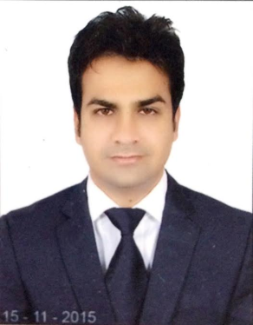

FAIZ

Objective | To excel in the field of Passenger service / Office Assistant utilizing my exiting knowledge and ability, optimally. Seeking a challenging position in a dynamic Multinational organization with opportunities to grow professionally. Always a Target Oriented & team player.
Duration  2016-Presently  2013- 2015  2011-2013 | ETISALAT / FUTURE BRIGHT TECHNOLOGIES LLC.  Sales Executive  Dubai United Arab Emirates  AUGUST 2016- Present  RESPONSIBILITIES:  - Selling Post Paid Plans , Business Plans and Post Plans with Latest Phones  - Providing highest standard of customer service  - Delivering proper information in regards with customer inquiries and products  - Achieve monthly targets  - Prepare daily sales report and perform all the follow-ups with regards to the team leader.  Attends the trainings and meetings related to the update of plans  GANPATI MOBILE STORE Sales Executive Responsibilities:  - Handle the customers.  - Maintains relationships with clients by providing support, information, and guidance.  - Identifies product improvements or new products by remaining current on industry trends, market activities, and competitors.  - Sells products by establishing contact and developing relationships with prospects.  ICONS REALPROP PVT.LTD.  Sales Executive  Responsibilities:  - Generate the sales leads and close them  - Providing the details of properties price, size, location and arrange visit to view the properties  - Place advertisements in the property pages of local newspapers and online  - Answer client’s questions regarding construction work, financing, maintenance, repairs, and appraisals  - Ensure to achieve monthly target  - Analyzing market trends to determine competitive market prices  - Helps in loaning process
Education | - (MBA)Master of Business Administration from Uttar Pradesh technical university Lucknow 2011  - Concentrating in Marketing and Human Resource
Language Known | - English, Hindi, and Urdu
Hobbies | - Reading, Traveling, Cricket.
Additional Qualification | MS Word ,PowerPoint, Microsoft Excel

Personal details:

Name : FAIZ
Nationality : Indian
Date of Birth : 10/12/1988
Visa status : Employed Visa

I hereby declare that above information is true and to correct to the best of my knowledge.

