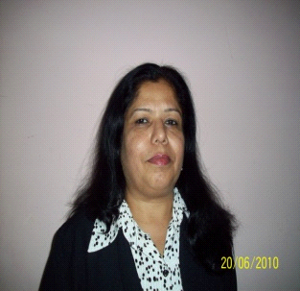

Barbara

Barbara.27948@2freemail.com

Resume Title: Administration/ Teacher

I am a career oriented, skillful and conscientious individual seeking for a utilitarian position.
Diligently I achieve the assignment with self-motivation, possessing great potential.
Working experience in Dubai as a Teacher

Current Employer: Winchester School Outh Metha from Sep 2011 onwards
Current Designation: Shadow Teacher to a Down Syndromes girl Year 2.
Previous Employer: Winchester Jabel Ali Assistant Teacher for year 4th from September 2011 to September 2013
Dubai first school as class teacher from Sep 2008 to Jun 2010

Working experience as a Secretary from 2007 till 2008
20 June 2007 till date worked in Emmex System Trading LLC.
As administrator & accounts assistant
Education & Certification
Bachelor of Commerce passed out in year 1984 from Mumbai University
Subject of specialization: English
Secretarial Practice & Office Administration
Accountancy
Company Law
Economics.
Professional Courses
Certificate in Basic Diploma in Computer Application like Windows NT, Internet
Microsoft Office 2000 from Boston Computer Technologies.

Additional Qualification
National Physical Efficiency Test (seniors) conducted in the year 1982 rewarded Two Stars.
I was certified by PENTA for my Writing Course in Dubai in the year 2010.

Working experience in India from 1984 to 2005
1984 till 2005 - I was coaching students in Mumbai from K.G till Grade Tenth all subjects.
Worked as a Assistant Teacher in a Special Needs school in Dilkush in Mumbai on temporary basis for
18 months.
From 1998 till 2004 worked for M/s. Airavat Construction in Mumbai as a 0ffice administrator.

Key Points
Proficient in Computer- Microsoft Word, MS Excel, MS PowerPoint, Internet, Microsoft Outlook
Scanning Documents and Filing
Versatile and trustworthy person, effective communicator, both verbal and written
Friendly with positive attitude proven team player
Well-organized
Self-motivated and
Easy to adapt to changes and ideas.
Personal Details
Visa : Employment visa
Languages spoken: English, Hindi, Urdu, Marathi
Extra Curricular activities: Reading, Singing, Cooking and Net Surfing
Personal details will be provided on request.

