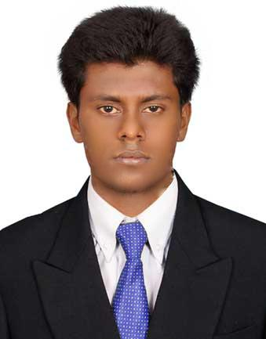
MUTHU KUMAR SUNDARRAJ

Murjanet al khaleej building, Flat number – 202, Muraqqabat - road,

Deira, Dubai

E-mail ID : muthumechfame@gmail.com

S u m m a r y :

I was working for CONTROL PLAN for all activities in production and maintenance activities.
- Production schedules, along with resource allocation and machine loading for optimum output,

- Plant start up and shutdown activities,

- Planning day-to-day strategies,

- Marketing requirement and meeting customer satisfaction

- Efficiency monitoring and control,

- Preparing manuals & work instructions for production operations for the unit,

- Efficiency monitoring and control, trouble shooting and safety, health & environment system.

A r e a o f i n t e r e s t :
Power plant.
Manufacturing
Technology.

Theory of Mechanism.
Automobile engineering.

O B J E C T I V E :

To secure a professional position that utilizes my skills, experience and abilities to the fullest in the industry that offers challenges, security and professional growth while being resourceful, innovative and flexible.

E X P E R I E N C E :
P R O D U C T I O N E N G I N E E R ,

L.G. Balakrishnan & Bros Limited, Coimbatore. 2013 – Present

P R O J E C T W O R K ,
Roots Industries India Limited, Coimbatore.

2012 – 2013

E D U C A T I O N :

- B.E., Mechanical Engineering in Anna University, 2013 passed out with70%.

- HSC in Government Higher Secondary School, 2009 passed out with 85%.

- SSLC in Government Higher Secondary School, 2007 passed out with 63%.

P R O F E S S I O N A L S K I L L S E T :
- BULATS (Business Language Testing Service) from Anna University+ University of Cambridge
- Pro E (certified from UMS Technologies centre)

- Auto cad (learned)

- Completed HDCA (Honors diploma in computer application) with first class

E x t r a - c u r r i c u l a r

A c t i v i t i e s :

Won the BRONZE MEDAL in the Badminton game at ANNA UNIVERSITY CHENNAI-Zonal sports 2012-2013
Participated in badminton matches at college level and club matches.
P e r s o n a l s k i l l s :

Hard Working,
Flexible,
Leadership Quality.
H o b b i e s :

Playing games,
Surfing the Internet,
Listening to songs.
P e r s o n a l D e t a i l s :
Visa status : Visit visa

Date of birth : 01-Mar-1992

Nationality : Indian

Marital Status : Single

Linguistic : English &Tamil
P R O J E C T S :

Design of semi automatic work piece handling for riveting operation.

DESCRIPTION: To reducing the time, eliminate two operators and increasing the productivity by using of this semi automatic work piece handling method.

Semi automatic releasing of star delta starter.

DESCRIPTION: To prevent the motor from the power supply by releasing of starter automatically after the water level decreasing in the foot valve.

C O - C U R R I C U L A R A C T I V I T I E S :

.

- Undergone Implant training in TEMPOTECH automobile, Coimbatore
- Presented a paper on AUTOMOBILE EMISSION CONTROL TECHNOLOGY conducted by department of

Mechanical Engineering at S.N.S COLLEGE OF TECHNOLOGY, Coimbatore
- Attended national level workshop on ETHICAL HACKING & INFORMATION SECURITY conducted by KYRION DIGITAL SECURITIES (IIT Delhi alumni venture) at SASURIE ACADEMY OF ENGINEERING, Coimbatore

- Attended a national level workshop on COMPUTATIONAL FLUID DYNAMICS organized by the department of

Aeronautical Engineering at NEHRU INSTITUTE OF ENGINEERING AND TECHNOLOGIES, Coimbatore.

I, MUTHU KUMAR SUNDARRAJ, hereby confirm that the information given above is true to the best of my knowledge.
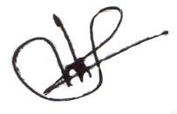

(MUTHUKUMAR SUNDARRAJ)

