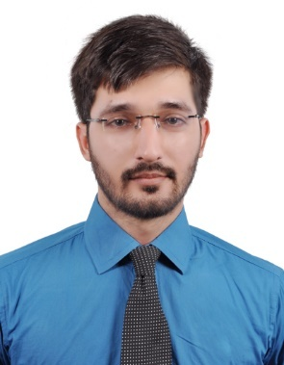
Curriculum Vitae

Muhammad
Muhammad.262329@2freemail.com

Objectives

Seeking to be employed in a firm where I can grow in terms of skills and knowledge.

Technical Skills

- ASP.NET Web forms | - C#
- Windows forms | - WPF
- HTML5 / CSS3 | - JavaScript / JQuery
- RESTful Web services (JSON & XML)  - ASP MVC 5 (Beginner Level) | - SQL queries & SP (ADO.NET)  - Crystal Reports
- N-Tier / Layer Architecture | - Devices integration

Experience

Company | Datasoft Solutions (Pvt.) Ltd.
Title | Software Engineer
Location | Karachi, Pakistan
Duration | December 2015 – Present
Major Responsibilities | - Developing solutions using N-Tier architecture.  - Optimizing code, queries and stored procedures.  - Reporting in Crystal Report 13.0.  - Developing and consuming SOAP services.  - Using Technology Visual Studio 2013/2015, .NET 4.0 /4.5, C#, SQL Server 2012/2014, WebForms, WinForms.  - Coding, Testing, Debugging, Modifications and Maintenance.

Company | PEBSol (Professional E Business Solution)
Title | .NET Developer
Location | Karachi, Pakistan
Duration | October 2013 – April 2015 (1 year, 7 months)
Major Responsibilities | - Developing solutions using N-Layer architecture.  - Worked on Attendance machine App, Integration of Bio Matric machines, GSM Modems, Barcode Scanners.  - Reporting in Crystal Report 13.0  - Using Technology Visual Studio 2013/2015, .NET 4.0 /4.5, C#, SQL Server 2012/2014, WebForms, WinForms.  - Database design & development, Workflow, Coding, Testing, Debugging, Modifications and Maintenance.

Projects

- DataSoft ERP: - DataSoft project
- Online Clothes Shopping Cart: - Freelance project (underdevelopment)
- Online Real Estate: - Freelance project (underdevelopment)
- School Management System: - PEBSol project.
- Inventory Management System: - PEBSol project (for Silver Textile).
- HR Management System: - PEBSol project.
- E Voting System: - BS Final year project.

Academics

- 4 years Bachelors (BS) in Computer Science from IBT (Institute of Business and Technology), with 3.54 CGPA, Karachi in 2013.
- Intermediate in Computer Science from Sheikh Khalifa Bin Zayed Arab Pakistan, College, Abu Dhabi, UAE in 2008.
- Matriculation in Computer Science from Sheikh Khalifa Bin Zayed Arab Pakistan, College, Abu Dhabi, UAE in 2006.

Courses Training & Certifications

- Basic OOPS concepts (JAVA) from INTRA computer learning center, Karachi, Pakistan in 2012.
- Basic MS SQL 2008 from INTRA computer learning center, Karachi, Pakistan in 2012.
- ASP.NET from AFT computer institute, Karachi, Pakistan in 2013.

Personal Information

Date of Birth | 19th January 1990
Languages | English, Urdu

