DAREL
E-Mail: darel.262835@2freemail.com

ENTERPRISING SALES & MARKETING LEADER
■ Profit Centre Operations ■ Project & Industrial Sales & Marketing ■ P&L Management
A multi-faceted professional with strong exposure in improving top-line & bottom-line of organizations and increasing profitability by re-organizing direction towards profitability, visibility & growth

Profile Summary
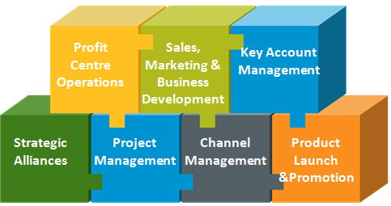

Achievement-driven professional with nearly 14 years of outstanding success in spearheading the entire gamut of profit centre operations

Specialization in driving sales of high value industrial products across the globe

Skilled in strategic planning and implementation of best practices & strong management systems

Adept in conceiving & implementing ideas that fuel market place presence and drive revenue; evolved & executed strategies that led to acquisition of business from high profile accounts

Hold the credit of developing new markets from scratch and consistently enhancing business operations; outstanding success in building and maintaining relationships with key corporate decision makers

Proven ability to meet production targets and enhance operational effectiveness within cost & quality parameters

Enterprising and dynamic with well-rounded leadership, communication, planning, analytical and ownership skills; excellence in directing cross-functional teams to deliver results
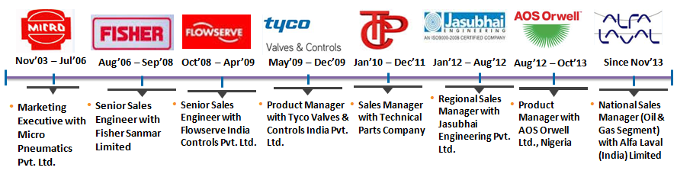

Business Skills
- Conceptualising & implementing competitive sales strategies and leading organization wide sales personnel towards achievement of sales goals; developing processes to create an effective sales organization

Proactively identifying changes in market demand and modifying strategies for expansion of market share & achievement of revenue targets; overseeing the preparation of monthly, quarterly and annual sales forecasts and plans to meet/exceed the same; maintaining competitive knowledge to create and adjust sales strategies

Managing the entire gamut of techno-commercial operations with accountability of feasibility studies, enquiry generations, tendering, order execution, collection of receivables and provision of after-sales service

Building and maintaining strong relationships with institutional clients for repeat business; establishing large volume & high profit accounts and maintaining top & bottom line profitability

Providing advisory to Product Management Team for launch of products

Providing leadership through effective communication of vision, active coaching and development while comparing sales results to goals and taking appropriate action to correct when necessary

Ensuring effective hiring, orientation, training, development and retention of sales staff; demonstrating a dynamic leadership style that will motivate and empower a team to ensure successful launch of new products

Key Accounts Captured

- Offshore: SPDC, Mobil, Chevron, Total, Afren, Addax, British Gas, Oil & Natural Gas Corporation, Supreme Offshore, Hal Offshore, Iranian Offshore, Leighton, Swiber Offshore, Great Offshore, Essar Offshore, Afcons Infrastructure Limited, Dolphin Offshore, Bechtel and Das Offshore
- Refineries: PHRC, KRPC, WRPC, NPDC, IOCL, HPCL, BPCL, Reliance and Essar
- Fertilizers: Dhangote, Indorama, Notore, Zuari Agro, Gujrat Narmada Fertlizers Ltd. (GNFC), RCF (Mahul & Thal), Coromandal and Deepak Fertilizers
- Chemicals and Bulk Drugs: German Remedies, Hindustan Lever, Lupin, Glenmark, CIPLA, Nestle, VVF, IG Petro, Coca Cola, Safoni Aventis, Binani, Pidilite, NOCIL and National Peroxide
- Consultants: AKPG, SNC Lavalin, TICB, Chemithon, SWRL, Chemtex, Linde, PDIL, IOTL, L&T, UHDE, Punj Lloyd, Kazstroy, SK E&C, Toyo, Technip, Naftogaz, Lurgi, Doosan, Desein, Samsung, Fernas, Bridge & Roof, Petron, Development Consultants, Fichtner, Procon, Mott Macdonald, Kalpataru, HDO, TCE, Tata Projects, Gammon, Kilburn, Fluor Daniel, TGE Gas, SMS Siemag, Praj, IBI Chematur, Indus Projects, Jacobs, Worley Parsons
- Iron & Steel: Vikram ISPAT, Sesa Goa, Viraj Profile, Mukand Ltd., JSPL and Tata Steel
- Power: Reliance Energy, Goa Energy, RGPPL (Ratnagiri Power Gas), Tata Power, India Bulls, MSEB and Lanco
- Shipyards: ABG, Pipavav, Goa, Bharati, Mazgaon Dock and Indian Navy
- OEMs: L&T MHI Boilers, Chemtrols, Furnace Fabrica, Heurtey Petrochem, General Instruments, Ion Exchange, Kirloskar Pneumatic, Thermax, Unitech Machines, GEA Process, Wipro Water and Coen Bharat

Organisational Experience

Jan’17 till Date with GR Green Life Energy Pvt. Ltd as a Freelance Consultant

- Promoting Solar Power Plants in the Indian territory

Nov’13 – Dec’16 with Alfa Laval (I) Limited, Navi Mumbai as National Sales Manager (Oil & Gas Segment)

Highlights:

- Successfully bagged large orders for:
  - Modularized Deck Boliers order from Tuff Offshore for an FPSO worth USD 10.4 Million.
  - Lynx Decanter Centrifuges from Rheochem (Newpark Company) for Cairn Energy projects worth USD 1.2 Mn
  - Water Injection Heater package from Cairn Energy worth USD .8 Mn
  - Diesel Centrifuge Package from Gol Offshore Ltd. for ONGC project worth USD .5 Mn
  - First Mud Cooler Package in India from Greatship (India) Limited for BG project worth USD .3 Mn
  - First Water Maker Package in India from Shelf Drilling for ONGC project worth USD 150 K.
- Holds the distinction of improving revenue growth by 600%
- Expanded business across markets of North, West, East and South India for Oil & Gas (Upstream & Midstream)
- Steered launch of new products such as Water Makers and Mud Coolers.
- Vendor registration of Water Maker & Shell & Tube Heat Exchanger (OLMI Brand) in ONGC Offshore Engineering services vendor list.

Aug’12 – Oct’13 with AOS Orwell Ltd., Nigeria as Product Manager

Highlights:
- Holds the distinction of spearheading sales of Control Valves, Automated Ball Valves & Industrial Regulators to leading clients in Nigeria; expanded business of Refining Segment across Western Nigeria
- Played a stellar role in achieving 2 times the set sales target and attaining 200% increase in revenue
- Conceptualized & implemented business plan for Valve Service Centre in Nigeria involving negotiation with customers for CNC Machines, Valve Test Bench, Tool & Tackles,
- Instrumental in acquiring 2 large Offshore project orders for AOS Orwell Ltd. from Chevron worth USD 2 Mn for their Merin Water Injection & EGP 3B & GSEP projects

Jan’12 – Aug’12 with Jasubhai Engineering Pvt. Ltd., Navi Mumbai as Regional Sales Manager

Highlights:
- Attained 30 % increase in revenue
- Developed business of Power & Water segments across the new territories of Gujarat & Goa

Jan’10 – Dec’11 with Technical Parts Company, Mumbai as Sales Manager

Highlights:
- Independently set up and managed business of Industrial & Construction Products Division across India
- Improved order booking from Rs. 3 Crores in 2009 to Rs. 12 Crores in 2010; attained 400% increase in revenue
- Developed business of Oil & Gas and Refining segments across new territories of Mumbai & Pune for Pipes and Piping Products.
- Steered the acquisition of high profile accounts across Western & Northern India

May’09 – Dec’09 with Tyco Valves & Controls India Pvt. Ltd., Navi Mumbai as Product Manager

Highlights:
- Attained 30% growth in business; developed business of Refining Segment across Gujarat
- Steered the acquisition of high profile accounts across Western India from different industrial segments

Oct’08 – Apr’09 with Flowserve India Controls Pvt. Ltd., Mumbai as Senior Sales Engineer

Highlight:
- Played a key role in vendor enlistment of Flowserve - FCD with SNC Lavalin Engineering India Pvt. Ltd. thereby ensuring a regular flow of huge enquiries for their ANRACK Alumina Project at Vishakapatnam
- Steered the acquisition of high profile accounts across Western India from different industrial segments

Aug’06 – Sep’08 with Fisher Sanmar Limited, Mumbai as Senior Sales Engineer
Highlight:
- Successfully increased Spares Business in ONGC from Rs. 10 Lakhs to 3 Crores in just 2 years
- Steered the acquisition of CCOE (Chief Controller of Explosives) Certification for Fisher Digital Valve Positioners (DVC) and Digital level Controllers (DLC) thereby ensuring Fisher’s reputation in the Industry for Digital & Smart Products and increasing business prospects for SMART products manifold
- Received Appreciation Letter from British Gas for delivering a 20” Control Valve to their Hazira Site in just 47 days
- Steered the acquisition of high profile accounts across Western India from different industrial segments such as Oil & Gas and Power

COMMENCED CAREER: Nov’03 – Jul’06 with Micro Pneumatics Pvt. Ltd., Mumbai as Marketing Executive

Education
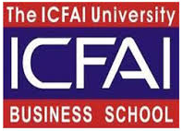
- Diploma in Business Management (International Business) from ICFAI University in 2009
- Bachelor of Engineering (Instrumentation) from A.C Patil COE, Mumbai University in 2003
- International Executive Masters in Business from SDA Bocconi (2017 – 2019)
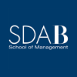

Trainings Attended

- CV1 Training on Control Valves in Flowserve
- Training on Smart Positioners in Fisher
- 6 days Training on Selling in Competitive Environment by Mercury Goldman International
- 1300 Phase III Control Valves Training on Sizing & Selection of Control Valves in Emerson (LBP of AOS Orwell)
- 1751/ 1752 Training on Fundamentals of Fieldvue Digital Instruments with Handheld Communicators/ Valve Link and Diagnostics for Fieldvue Operations attended in Emerson FZE, Dubai
- Training on GPHE X-cellence attended in Alfa Laval, Pune
- Training on 2Touch/ BCC for Decanters attended in Alfa Laval, Pune
- ALPAS 3, Offshore Oil & Gas Processing attended in Alfa Laval, Kuala Lumpur, Malaysia
- Rooftop Solar Grid Engineer from National Institute of Solar Energy, Gurugram, Haryana
Course numberSGJ/Q0106

IT Skills

Operating Systems: Windows 7
Office Tools: MS Office
Languages: C Programming / Pascal

Personal Details

Date of Birth: 17th April 1981
Languages Known: English, Hindi and Marathi
Passport Details: valid till 21st May 2025.

