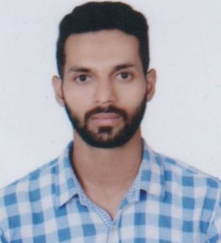
ALI
Place: Dubai on visit visa till 1st March 2018.
E-mail ID: ali.262867@2freemail.com

Career Objective:
A dedicated technocrat committed to profile a progressive career in Mechanical and Automation Engineering domain while contributing to industry’s growth with innovative technologies.

Experience:
- Mahanagat Gas Limited: Mumbai, India, August-September 2017
- Project Manage:
  - To lead the team for achieving the project objectives.
  - To define and clarify the project scope.
  - To develop policies and procedures to support the achievements of project objectives.
  - To determine and take corrective action

Technical Skill Set:
Software: | AutoCAD
Programing Language: | C

Industrial Training:
- Project: Maintenance of machining tool on Lathe machine, Milling machine, Drilling machine.
- Organization: Government Opium and Alkaloid Factory, Ghazipur (U.P)

U.G. Project undertaken:
- Title-Three Axis Industrial Robot
- Description- In this project Asmo motor is used in which worm gears are present inside it, due to which output shaft is independent of input shaft. Industrial robots a promising, cost-saving and flexible alternative for machining applications.
- My Contribution- Analysis and Designing

Area of Interest:
- Project Management
- Automobile Engineering
- Designing of Machine Parts
- Service Engineer
- Mechatronics

Academic Profile:
Qualifications | Specialization | Board/Univ. | Year | CGPA/%age
B-Tech | Mechanical and Automation | AMITY UNIVERSITY | 2017 | 64.8
Std- XII | Math, Physics, Chemistry, | M.P. BOARD | 2013 | 66.8
Std- X | Math, Science, Social Science, | M.P. BOARD | 2010 | 62

Achievements:
- Participant in Workshop of “Automobile Engineering Design” organized at IIT Delhi during Tryst-2014.
- Participated in Writing Competition at state level

Extra-Curricular Activities:
- One month training at Automobile Workshop
- Co-ordinated in Conference in Key Aspects of interface between Biology and Engineering.
- Worked as a Cultural Event Coordinator during Amiphoria 2015
- Participated in a Cricket Championship during Sangathan 2014
Key-Competence:
- Enthusiasm
- Leadership Skill
- Diagnose Bike Faults
- Language Known- English, Urdu, Hindi, German(Basic)

Personal Details:
- Date of Birth : 08/06/1994
- Sex : Male
- Marital Status : Unmarried
- Visa Status : Visit Visa

References will be furnished on request

Ali

