NASEEM
A versatile professional, targeting senior-level assignments in Project Management, General Administration and Client Relationship Management with an organization of repute, preferably in Overseas (Canada/Australia) / Middle East / India
naseem.263084@2freemail.com
Profile Summary

- A dynamic professional with nearly 14 years of experience inProject Management & Office Administration
- Currently working with AHCEC Saudia Arabia contractual assignment with Sadara Chemical Companyas Project support Supervisor
- Proficient in providing input for preparation of project implementation schedule including field activities & associated interfaces
- Skilled at directing, controlling and managing all aspects of the project including in-house engineering, procurement, construction, interfaces, administration functions and all external work undertaken by contractors & consultants
- Experienced in maintaining activities in coordination with internal / external departments for ensuring smooth functioning of business operations
- Competent in identifying, developing and negotiating with vendors for the procurement of necessary items, supplies and material for the smooth running of operations of the organization
- Accomplished, ambitious & dedicated professional with expertise in providing training / development, instruction & consulting
Education

B.Com. from Calicut University, Kerala, India in 1997
Diploma in Automobile Engineering from Tamil Nadu State Government, India in 2001

Area of Excellence

Project Management | Documentation & Reporting | Liaison & Coordination
Team Management | Training & Development | Fixed Assets Management
General Administration | Client Relationship Management | Data Management
Career Timeline

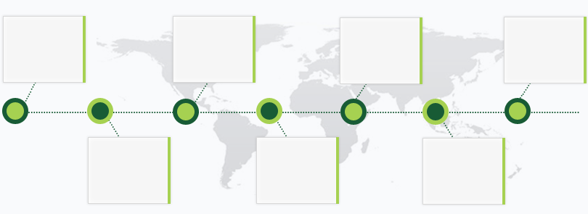
Jun’06 – Dec’06Kharafi International Limited, Kuwait

Mar’03 - Mar’06HEISCO Heavy Engineering & Industrial ShipyardCompany, Kuwait

Jan’10 - Apr’12
Skikda Refinery Rehabilitation & AdaptationProject Algeria,North Africa

Jul’09 - Nov ’09ENI Congo (Africa West) Sicim Mboundi Gas GatheringProject

Since Oct’12AHCEC Saudia Arabia contractualassignment with Sadara Chemical Company
Apr’07 -Oct’08Saipem Saudia Arabia Water Injection Pump Station

Jan’09 – Jun’09Punj Lloyd Qatar Strategic Gas TransmissionProject

Work Experience

Since Oct’12
AHCEC Saudia Arabia contractual assignment with Sadara Chemical Company as
Project Supervisor
Key Result Areas:
- Performing activities such as monitoring documentation & reports, identifying process improvement areas, ensuringdocument master list is being maintained and updated in a timely manner, and so on
- Coordinating with Dow clients; understanding their requirements, and building strong working relationships
- Meeting the turn-around time for the storage, upload and safekeeping of documents and assuring proper indexing of hardcopy files
- Managing the day-to-day production related activities & schedules and allocating work for achieving the monthly production targets
- Taking stringent quality measures including preparation / maintenance of necessary documents to ensure compliance with standards and customer requirements
- Coordinating projects with accountability for strategic utilization & deployment of available resources to achieve organizational objectives
- Coordinating with the travel agent to arrange flights, ground transportation Taxi & Car rental, hotel booking for new hires
- Possess sound knowledge in use of spreadsheets, database, word processing and selected job specific software
- Developing & presenting reports to management, site personals and sub-contractors
- Providing drawings and documents to pre-determined users
- Directing the preparation and modification of reports, specifications, plans, construction schedules, environmental impact studies, and designs for project.
- Nurturing relationship with clients after project completion to assure future work from the clients.
Highlights:
- Reviewed project schedule and progress forensuring on-time completion; directed projects worth US$ 1Billion.
- Supervised the vendor in for designing & manufacturing for project adhering to contract specifications, international standards & external statutory requirements related to safety, health & environment.
- Directed project from conception to completion, brought the project running behind schedule back on track and created & presented an excellent image of the company
Jan’10 - Apr’12

Skikda Refinery Rehabilitation & Adaptation Project Algeria, North Africa
as Document Controller Manager
Key Result Areas:
- Engaged in administering project oversight, pre-project planning, resource management, scheduling, budgeting, and project status reporting
- Managed a team of 4 members, worked as technical liaison between management, employees & engineers, and discussed on-going issues and project details, on-going issues and project details
- Recommended solutions to upper management regarding problem, research & resolution
- Supported in the preparation of bid packages in both electronic and hard copy form; supervised comprehensive document review process while maintaining a document distribution matrix, maintained deliverable list in Project Document & Material Control (PDMC) access database, and so on
- Gathered detailed status reports on documentation from Contractors and provided status on progressive DFO, assisted clients and vendors on technical issues and transmitted required drawings and documents
- Directed project team-MDR and ensured all gate documents are identified and uploaded into U-Docs as well as rendered support regarding the projects document control process and organizational policies, procedures and workflows
- Interacted with project contractors, supervised turnover and handover process and workflow for all project documentation including project closeout and delivery to operations, and so on

Highlights:
- Successfully executed Front End Engineering Design (FEED), Detailed Design, and Vendor Documentation through XX measures
- Single-handedly tracked project deliverables in a Microsoft Access Database

Previous Experience
Jul’09 – Nov’09 with ENI Congo (Africa West) Sicim Mboundi Gas Gathering Project as LeadDocument Controller/ Administrate Assistant

Jan’09 – Jun’09 with Punj Lloyd Qatar Strategic Gas Transmission Project as Lead Document Controller

Apr’07 – Oct’08 with Saipem Saudia Arabia Water Injection Pump Station as Lead Document Controller

Jun’06 -Dec’06 with Kharafi International Limited, Kuwaitas Lead Document Controller

Mar’03 -Mar’06 with HEISCO Heavy Engineering & Industrial Shipyard Company, Kuwaitas Document Controller / Administrate

Jan’01 -Dec’02 with American Life Insurance Company, Dubaias Sales Representative

IT Skills

Operating Systems: MS Windows
Office Automation Tools: MS Office 2000/ 2003, Internet Applications
Autocad Certified, Tally Certified.
Trainings
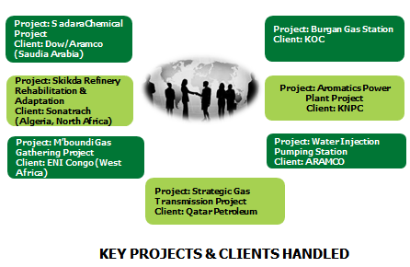
- Office Administration Training
- Life Critical Training
- Leadership & Communication
- EHS Training Office Safety
- Defensive driving

Personal Details

Date of Birth:20th February 1976
Nationality: Indian
Marital Status: Married
Languages: English, Arabic, & Hindi
Saudi Driving License: Yes

