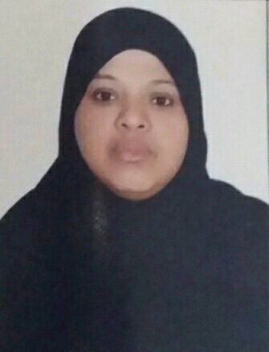
SWALHA
SWALHA.263255@2freemail.com
CAREER OBJECTIVE:
To Secure a rewarding assignment to grow professionally and further enhance my skills, knowledge and experience to face and overcome the challenges of today's changing work environment.
ACADEMIC QUALIFICATIONS:
ACCPAC (LEVEL I) 1996
IMIS (Institute of Management Information System) 1995
This consists of six modules; Accounting Methods, Data Processing I & ii, Quantitative Methods, Programming Project and Peoples' Communication Information in an Organization. Passed all except Programming Project.
SECONDARY: Coast Girls' High School 1991-1994.
PROFESSIONAL EXPERIENCE:
BIJTEX LTD. Accounts Clerk/Secretary . 1996-2002
THE DUTIES :
Book keeping all the transactions taking place and transferring both to ledgers manually and computerized accounting
Namely; QuickBooks
Preparing of invoices
Writing cheques
Accounts payable
Account receivable
Drafting of letters
Answering telephone

OTHER SKILLS:
Data Base iiii Programming Language
Microsoft office tools
Systematic software (Accounting software)
Quick Books Version 5(Accounting software)
Internet
Additional Information:
Nationality : Kenyan
Marital Status: Married with two kids
Language: English and Swahili (Expert) Arabic Intermediate
License: UAE Driving License
Date of Birth: 11th Sept 1976
Part time: I do Data Entry jobs on part time and translation
Hobbies:
Listening to Quran, Taking care and teaching kids.

