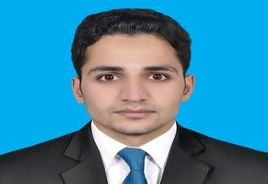CAREER OBJECTIVE:
Muhammad
Registered Electrical Engineer from PEC ( Pakistan Engineering Council )
Email: Muhammad.263393@2freemail.com

I want to take the challenging position in a professional organization that allows me to utilize my abilities to assist the development. Moreover I intend to get every possible opportunity to enhance my professional skills.

EXPERTISE:

- Outstanding command over verbal and non-verbal communicative & interpersonal skills.

- 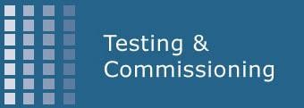Excellent Technical and Engineering Skills.

- MS Office(All versions, esp. MS Word, MS Power Point and MS Excel)

- MATLAB/SIMULINK, Proteus.

- AutoCAD(Good command over 2D Drafting)

- Good knowledge about managing electrical designs and development processes according to DEWA and making load schedules.

- Flair to organize & prioritize tasks to meet deadlines.

- Ability to manage multiple projects with minimal supervision.

- Confidently able to work independently or in a team to deal effectively with educators & employees.

- Have a good level command over English Language.

PROFESSIONAL TRAININGS & WORKSHOPS:

  - Title: Awareness & implementation of ISO/IEC 17025

  - Title: Traceability & Uncertainty in Measurement for Testing and Calibration Labs

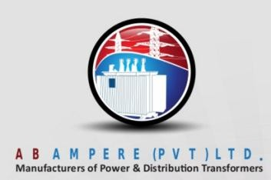PROFESSIONAL WORK EXPERIENCE: (2 Years)

Organization: AB Ampere Transformers (Pvt) Ltd. Designation: Testing & Commissioning Engineer Tenure: February 2014 to January 2016 Responsibilities:

- Routine Testing of Three Phase Oil immersed hermetically sealed type Distribution Transformers under IEC- 60076 and WAPDA(Pakistan) Specifications DDS-84:2007 (A-5) and preparing of test reports.

- Handling of Testing Lab Management System (LMS) according to ISO/IEC 17025:2005

- Estimate uncertainty in the test results.

- To take corrective/preventive action.

- To assist Manager Engineering in R & D.

- Responsible to ensure that incoming Raw material is according to WAPDA Standards & Specifications.

- Responsible for preparing of reports of parametric and di-electric strength of raw material and any other (intra office & inter office documentation) needed timely.

- Acts as a communication channel between Quality Assurance department and Quality Control department.

ACADEMIC EDUCATION:

Bachelor of Science in Electrical Power Engineering YEAR
Institute: COMSATS Institute of Information Technology 2010-2014

Higher Secondary School Certificate (Pre - Engineering) 2007-2009

INTERESTS AND HOBBIES:

  - Hobbies include anything to do in arts, music, poetry, philosophy.
  - Enjoy and actively participate in a wide variety of sports and creative activities.

PERSONAL INFORMATION:

Date of Birth : January 14, 1992
Religion : Islam
Nationality : Pakistani

