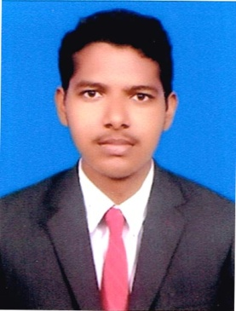
RESUME

JAFAR
JAFAR.263862@2freemail.com

Objective

To work efficiently and effectively as well as grow with an organization and constantly improve my technical skills through continuous learning.

Academic Details

UG

Course : B.COM., CA (2011 - 2014)

University : Manonmaniyam Sundaranar University, Tirunelveli

College : Sadakathullah Appa College, Tirunelveli.

Overall Percentage : 65%

XII

School : Mohamedia Hr. Sec. School, Chittarkottai, Ramanathapuram

Year of passing : March – 2011

Percentage of marks : 64.8%

EXPERIENCE:

- HOTEL NIVEDHITHA Palaiyamkottai Year 2014-2015 work as Cashier and Management Incharge.

COMPUTER SKILLS:

      - Tally ERP 9.0
      - Cum Internet Programmers
      - Fox Pro
      - Java
      - MS.Office

Area Of Interest
      - Daily Accounts Maintain
      - Sales Tax
      - VAT
      - Monthly Return
      - E – File

PERSONAL DETAILS

Date of Birth : 28.03.1994

Gender : Male

Languages known : English & Tamil (R & W)

Hobbies : Reading books, Basket Ball, Cricket, Cheese

DECLARATION

I here by declare that the details provided above are true to the best of my knowledge.

