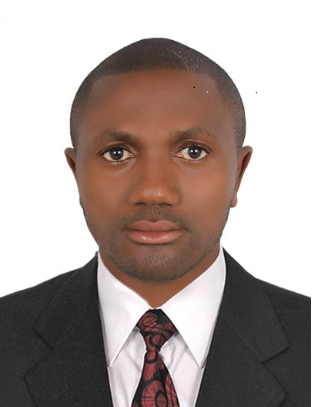CURRICULUM VITAE
NAME: CHENWIE
CHENWIE.264174@2freemail.com
Visa status EMPLOYMENT VISA COMPLETED (FINISHED CONTRACT)

OBJECTIVES
A highly talented Waiter with extensive experience in coordinating entire station and communicating with front- and back-of-the-house personnel to provide a dining experience that meets or exceeds guest expectations; processing guest orders to ensure that all items are prepared properly and on a timely basis

WORK EXPERIENCE AND EMPLOYMENT HISTORY
AL QAHERAH 194O RESTAURANT AND CAFÉ DUBAI MARINA
25/FEBRUARY/2014 till Now
WAITER
- Meets and exceeds customer and team member expectations by providing outstanding Service & teamwork:
- Provides value added service to customers by doing whatever is reasonable and possible to meet or exceed customer expectations
- Communicates effectively with customers, co-workers and supervisors
- Demonstrates teamwork by co-operating and assisting co-workers as needed
- Sets up chairs and tables in the restaurant before it opens for operation
- Wipes tables and chairs and polishes china, glassware and cutlery both on tables and service stations
- Fills up service station, supplies the service station during service hours, with necessary condiments, china, glassware, linen and makes sure cutlery is always polished.
- Checks condiments and condiment stands.
- Knows all tables by numbers and seats, in order to serve the correct drink and dish to each guest.
- Takes food & drink orders from the guest, and forwards these orders by always using the Micros system.
- Serves food & drinks to the guest, applying correct sequence of service and making sure the guest gets all necessary condiments and accompaniments.
- Informs his assigned captain immediately of any irregularities or complaints
- Clears tables of dirty and empty glasses and dishes, replenishes drinks and changes ashtrays.
- Clears regularly the service station and keeps it clean and tidy.
- Farewells guests at departure whenever possible.

SKILLS
AL QAHERAH 194O RESTAURANT AND CAFÉ DUBAI MARINA
25/FEBRUARY/2014 till Now
WAITER
- Meets and exceeds customer and team member expectations by providing outstanding Service & teamwork:
- Provides value added service to customers by doing whatever is reasonable and possible to meet or exceed customer expectations
- Communicates effectively with customers, co-workers and supervisors
- Demonstrates teamwork by co-operating and assisting co-workers as needed
- Sets up chairs and tables in the restaurant before it opens for operation
- Wipes tables and chairs and polishes china, glassware and cutlery both on tables and service stations
- Fills up service station, supplies the service station during service hours, with necessary condiments, china, glassware, linen and makes sure cutlery is always polished.
- Checks condiments and condiment stands.
- Knows all tables by numbers and seats, in order to serve the correct drink and dish to each guest.
- Takes food & drink orders from the guest, and forwards these orders by always using the Micros system.
- Serves food & drinks to the guest, applying correct sequence of service and making sure the guest gets all necessary condiments and accompaniments.
- Informs his assigned captain immediately of any irregularities or complaints
- Clears tables of dirty and empty glasses and dishes, replenishes drinks and changes ashtrays.
- Clears regularly the service station and keeps it clean and tidy.

EDUCATIONAL BACKGROUND
Bachelor Degree in Sociology
LANGUAGES
–Fluent in English and French Language AND Arabic

