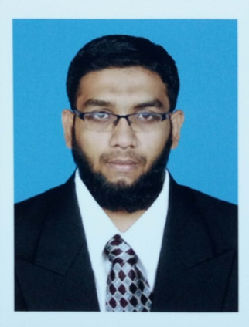
GHOUSE
Information Technology
System Administrator & Desktop Support
C/o-Mobile: +971502360357
Email-ID: ghouse.266143@2freemail.com

Objective
To pursue a challenging career and to be a part of a progressive and growth oriented organization that scope to enhance my knowledge and skills to cope up with the latest technological changes.
- B.TECH in Information Technology (IT)
Mohamed Sathak AJ College of Engineering,Anna University(Jun 2010-May 2013)
- Diploma in Information Technology (IT)
Krishnaswamy Memorial Polytechnic College, DOTE (Syllabus), (July 2007 – July 2010).
Certification
- MCSA Microsoft Certified System Administrator, Chennai
- CCNA Cisco Certified Network Associate, Chennai
Professional Experience

Company : ACSYS IT SOLUTION PVT LTD
Duration : AUG 2014 – DEC 2015
Designation : TRAINEE SYSTEM ADMINISTRATOR

Company : TELLIGENT TECHNOLOGY SOLUTIONS
Duration : JUN 2016 – DEC 2017
Designation : SYSTEM ADMINISTRATOR

Job Description
- Establishing networking environment by system configuration, directing system installation, defining, documenting, and enforcing system standards.
- Maintain the system updates,updating software and LAN connectivity troubleshoot
- Create and Installing DHCP,Active Directory for Windows Server
- Maintain system efficiency.
- Troubleshoot problems reported by users.
- Make recommendations for future upgrades.
- Maintain network and system security.
- Monitor networks to ensure security and availability to specific users.
- Evaluate and modify system's performance.
Computer Proficiency
- Microsoft Office (Excel, Word, PowerPoint).
- Hardware & Networking.
Self Attitude
- The burning desire for Self Improvement.
- Excellent Organization Skills.
- A good team leader and being positive.
Personal Details
- Date of Birth : 16.11.1990
- Nationality : Indian
- Marital Status : Single
- Languages Known : English, Tamil
- Passport Expiry : 11.04.2021

