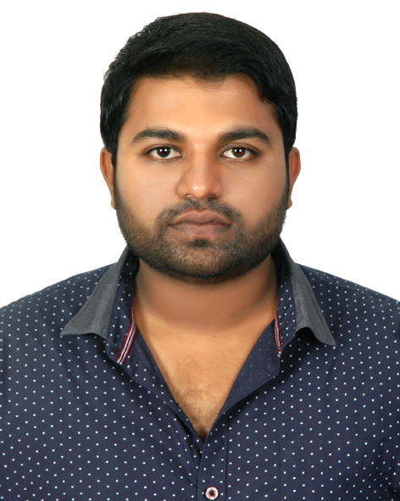
Meeran

OBJECTIVE:
Challenges and responsibilities drive me. I believe in succeeding through smart work and thus add value to myself and my organization.

Academic Records:

COURSE | YEAR | INSTITUTION | Division
SSLC | 2006 | Bangalore University | Second
PUC | 2008 | Bangalore University | First
B.B.M | 2013 | Bangalore University | Second

I have an overall IT experience of almost 5.5 years which includes expertise in Service Support, Team Management, MIS & Technical/Hardware expertise. This experience has also helped me in apprehending the leadership skills that has aided me in handling and managing a team or projects effectively.

PROFESSIONAL EXPERIENCE:
Company Name: Bangalore.
Feb 1st -2010 to March 15- 2011 (15 Months).

IT - Technical support Engineer

▪ Successfully handled the role of Technical support engineer undertaken the task of managing different Applications technical troubleshooting installation & configurations of blue wireless, WECAM, AT&T, Lotus notes related quires & IBM blue network port issues.
▪ Identified &analysed employee technical issues and resolving their technical problems by taking remote control of machine with comprehensive conversation.

▪ Efficiently managed entire day-to-day activities supporting across all over India IBM location technical issues & debugging and troubleshooting of the application.
▪ Drove the efforts across managing project life cycle from user requirements to system analysis & planning, implementation and deployment.
▪ Gained exposure in end-to-end communication remote supports technical knowledge and development from requirement analysis to system study, testing and debugging.

Designation: Remote Support Engineer

▪ Successfully after completing four months in current role position Technical support engineer then got transferred to Lenovo consumer project as a Remote support engineer.
▪ Where supporting all preloaded software & hardware related technical issue first contact point to address and validate issues of Lenovo laptop & desktop idea products in India.
▪ Direct contact with the Lenovo customers taking their system on remote and successfully solving their technical issues.

Responsibilities:

➢ Developing an understanding of how present and future business needs will impact the solution.
➢ Identifying and documenting all, technical, product and process requirements.
➢ Leading and coordinating a team of SME s and co-ordinate with the team to drive effective resolution.
➢ Understand customer and user requirements, their strategies, and their goals.
➢ Discuss and support those who market and sell the end-product of the project.
➢ Identify knowledge gaps, process gaps, communication gaps and ensure closure of the same through proper Training, Coaching and Mentoring.

Company Name: RAK/UAE
DEC -2011 to OCT-2015 (4 Years).
IT – Sales

- Networking with existing customers in order to maintain links and promote additional products and upgrade.
- Handling hardware or software problems and faults and referring on to specialist technical colleagues.
- Understanding customers' diverse, specific business needs and applying product knowledge to meet those needs.
- Providing technical advice to customers on all aspects of the installation and use of computer systems and networks, both before and after the sale.
- Decide whether the software or hardware needs adapting to meet the client's needs.
- Answering any technical questions the client might have.
- Ensure the timely and successful delivery of our solutions according to customer needs and objectives
- Ensure delivery of high quality customer support and act as a liaison between top tier clients and management.
- Managing and leading the project team and meeting deliverables like Service/ Sales Delivery & KPI.

IT - Technical support Engineer | FIFA U17 World cup
Ras-Al-Khaimah Football Stadium | Veritec Information Systems|UAE
SEP 2013 - Nov 2013

- Project in charge in Ras-Al-Khaimah Stadium, one of the six venues.
- Network infrastructure planning and Schematic Diagram presentation.
- Installing Switches, Patch panels, Router boards, Wi-Fi Access Points, PC’s, small MFP’s, Konica Minolta MFP’s, ISDN boxes and Configuring Routers.
- Monitoring the internet usage and maintaining the traffic.
- Remote monitoring of Wi-Fi Access points for avoiding conflictions.
- Give network support for the Media and Press conference.
- Network Trouble shooting, assisting the FIFA officers for printing, faxing and trouble shooting.

TECHNICAL/COMPUTER SKILLS:
- Completed hardware, networking, laptop maintenance, E+, CCNA, MCSE, MCSA
- Knowledge in the application of MS Word, Excel & MS PowerPoint.
- Capable of troubleshooting basic computer and Internet browser related problems.

NON-TECHNICAL SKILLS/STRENGTHS:
- People Management skills
- Able to balance competing priorities and tight deadlines
- I welcome any opportunity to train and demonstrate a willingness to teach others.
- Well organized and hard working with strong analytical skills
- Good interpersonal communication and writing skills
- Patient and diplomatic with strong negotiation skills
- Good planning, analytical and conceptual skills to evaluate business problems and apply knowledge to identify appropriate solutions
- Excellent customer service skills, strong interpersonal skills and strong written and verbal communication skills.

KEY SKILLSET:
Have an overall understanding of ITIL fundamentals & Project Lifecycle:
- People Management Skills
- Service Level Management skills
- Convincing Skills
- Escalation Skills
- Customer Service Skills
- Technical Skills
- Sales

PERSONAL PROFILE:

Date of Birth : 10th September 1988
Gender : Male
Nationality : Indian
Marital Status : Married
Driving License : U.A.E
Total Experience : 5.5 Years
Languages known : English, Hindi, Kannada
Job Requirement : HR and Management jobs also preferred

DECLARATION:

I hereby declare that the above details are true to the best of my knowledge.

Meeran

Meeran
CV NO: 1598610
Click to send CV No & get contact details of candidate


