“To obtain a position as a English Teacher that will utilize my strong dedication to children’s development and to their educational needs.”
POST APPLYING FOR ENGLISH TEACHER
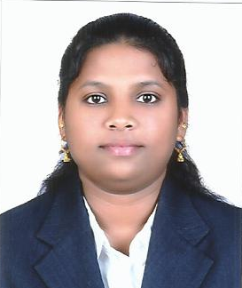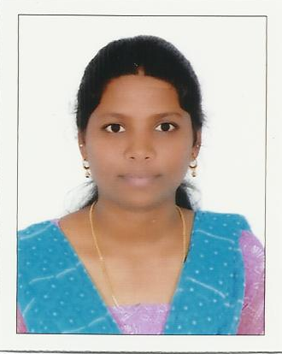
KALPANA (B.A., M.A., M.PHIL- (ENG LITT)).,B.ED
KALPANA.266620@2freemail.com

summary
“As I have worked as a lecturer in India ( from 2003-2008) and at present working as a school English teacher cum coordinator (2008-till date)in Beda zayed (Western region), Abudhabi, UAE. I m indeed Passionate in teaching English and experienced in mentoring and coaching in teaching British IGCSE (curriculum) school development, classroom management . And,I’m confident that my passion for the teachers’ and children’s development, along with my skills and experience that will enable to make a significant difference .”
Motivated to help students learn and be happy, healthy and well-behaved.
Soft Skills:
• Self motivated
• Initiative with a high level of energy.
• Strong verbal and personal communication skills.
• Decision making, critical thinking, organizing and planning
• Tolerant and flexible to different situations
QUALIFICATIONS – ACADEMIC CREDENTIALS
. Persuading B.ED at present in a recognized university.
IELTS course (JUNE 2014) –Band score 6.
- ICDL course (2010) –International Course Driving License. Beda Zayed, Abudhabhi, UAE.

- M.Phil., (2004 -2006)- Master of Philosophy in English .Madurai Kamaraj University, Palkalainagar, Madurai, Tamilnadu. India. Completed Course along with Viva- Voce in Nov 2006.
- M.A., (2001-2003) –Master of Arts in English , Vellalar college, Bharathiar University , Erode, Tamilnadu, India. Completed 4 semesters Course in April 2003.

- B.A., (1998 -2001) – Bachelor of Arts in English, Vellalar college, Bharathiar University , Erode, Tamilnadu, India. Completed 6 semesters Course in April 2001.

EXPERIENCE IN TEACHING POSITION
- English Language Teacher/ Coordinator – (10/2008 –till date )
Manar el Illm British Pvt School , Beda Zayed (western Region), Abudhabhi,UAE.
- Promoted language development skills through reading and storytelling.
- Conducted small group and individual classroom activities based on differentiated learning needs.
- Organized field trips to local parks, fire stations and zoos.
- Helped prepare daily lesson plans for activities and lessons.
- Encouraged students t o be understanding of and helpful to others.
- Communicated effectively with educators from various grade levels.
- Wrote daily and weekly lesson plans
- Lecturer in English - (06/2003 to 02/2008 )(5 years)
Vivekanandha Institutions, Thiruchencode, Tamilnadu, India
- Promoted language development skills through lecturing, delivering lessons reading and storytelling.
- Applied the positive reinforcement method to redirect negative behaviors.
- Encouraged students to be understanding of and helpful to others.
- Implemented literature stage programs to encourage student participation.
- Administered minor first aid to injured students.Enhancement students in English and overall personality.
- Prepared students for group discussion.Worked as a subordinate to my senior.
- Monitoring students in learning and making records of student’s progress.
AWARDS AND ACHIEVEMENT:
- Best outgoing student – Vellalar College,Erode,Tamilnadu,India-2003
- Excellent student at college level-2003
Extra curricular Activites:
- Managed cultural fest of college. Worked as a faculty advisor.
- Participated in story writing and writing competition in college.
RESEARCH WORK : THESIS IN M.Phil

- The Topic is ‘THE MANAWAKA NOVELS OF MARGARET LAWRENCE’ was successfully completed in the year 2006.
SEMINARS ATTENDED

- Participated in State level Seminar on ‘Women as a Preserver of Peace & happiness’ in Feb 2006.
- Participated in State level Seminar on ‘Indians in Indian writing in English’ in Sep 2006.
- Attended in one day Seminar on ‘Communication Made Easy’ in Jan 2003.
- All India Conference in Programming ‘Communicating of English’ – Two workshops & one symposium.

PASS PORT DETAILS:
- Date of issue : 29/05/2008
- Date of expiry : 28/05/2018

Hereby, I declare that the above furnished details are true to best of my knowledge.
Sincerely,

