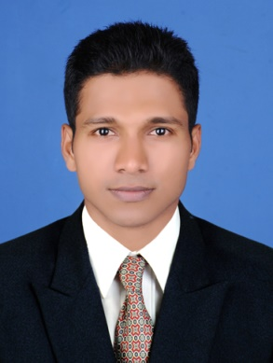
CURRICULAM VITAE

VAISHAK
Email: VAISHAK.268113@2freemail.com

OBJECTIVE
To obtain a challenging position that allows me to utilize my current skills to assist in advancing a business that offers a stable employment opportunity. I am also eager to learn new skills and business and technological advancement.

ACADEMIC QUALIFICATIONS
- Master in Business Administration - Specialized in Human Resource, Srinivas Institute of Management Studies, Mangalore University, India, in 2015.
- Bachelor in Business Management - Srinivas Institute Of Management Studies, Mangalore University, India, in 2013.

COMPUTERPROFICIENCY
- Microsoft Office (MS Word, Excel & Power Point)
- Tally ERP 9
OTHER QUALIFICATIONS
- Participation in 10days National Service scheme camp
- Second prize in Economics exhibition on the topic Business cycle
- Participated in Marketing exhibition in 2013
- Volunteer in Magma management fest in 2013
- Member in HR events managing committee of Magma management fest in 2014
- Team leader for MC committee of Magma management fest in 2014
- First price in HR forum activity
- Participated in National level Management fest at Shree Devi Institute Of Technology in 2015
- Best performer award for the year 2015

AREAS OF STRENGTH
- Determination, flexible & adaptable
- Trust worthy
- Willingness to take responsibility & able to work under pressure
- Honest, Self-confident and ambitious
- Able to learn tasks quickly
- Loyal & self motivated

WORK EXPERIENCE
* worked in “Umesh Kamath & Co.” as a Verification Officer for ‘Jio Sim’& Billing for Nokia And Reliance mobile phones in Kanhangad, during the period of 01.08.2016 to 20.09.2016.
- Maintaining records for the collected CAF
- Follow up regards with the approval and rejection status
- Coordinating the activities with field executives and activation officer
- Scanning of CAF and maintaining tracks for scanned CAF in daily basis
- Support for filling CAF
- Maintaining customer relationship and support customer service
- Billing of Nokia and Reliance mobile phones
- Cross checking and ensuring the complaints of damaged phones
- Maintaining record for damaged /complaint phones and replacing new phones to customers
- Making purchase order
- Checking stocks in daily basis.

*Worked in “Kanhangad Agencies” as a Marketing Executive for ‘Gulf Oil Lubricants’ in Kasaragod (dist.), Kerala , India, during the period of 22-07-2015 to 15-02-2016.
- Planning sales and strategy to attain the target
- Developing new customers
- Maintaining and upgrading customer data base
- Conducting market research by collecting feedback and suggestion from dealers/ customers
- Analyzing the prices, demand and competition
- Weekly visiting to all the dealers/ customers
- Building up and maintaining good relationship with dealer/ customers
- Making delivery of orders and collecting the payments
- Conducting meetings for dealers/ customers as well as mechanics
- Maintaining ledgers for the dealers/ customers
- Every Saturday making cross checking the accounts of dealers/ customers regarding the sales and receipts
- Preparing secondary sales data in every end of the month
- Providing timely feedback to the marketing head regarding the performance
- Preparations of sales promotion activities
- Making customer focused decisions
- Meet/ exceed the marketing performance measures

PERSONAL DETAILS

Date of Birth : 15th JUNE 1993
Gender : Male
Nationality : Indian
Religion : Hindu
Marital status : Single
Languages known : English, Hindi, Malayalam &Tamil

I hereby declare that all the above mentioned information is true and correct to the best of my knowledge and belief.

