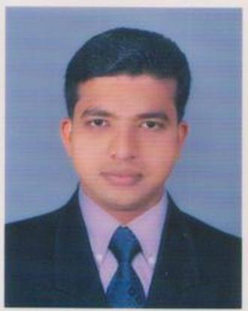
JOHN
John.268298@2freemail.com

SUMMARY
Experienced F&B manager with more than nine years proven track record including working for the leading Five Star hotel in India - The Leela.

With a Masters in Tourism Management and Administration, competent communication, people and guest management skills, I will prove to be an asset to your organization.

PROFESSIONAL EXPERIENCE

WelcomHotel Raviz Kadavu
A Five Star hotel in Calicut, Kerala
Restaurant Manager, Bar & BQT October 2013 - Present

*Second in command to the F&B manager * Manage and develop restaurant team, implement company discipline and brief team for upcoming events * Plan & forecast Sales, analyze and control P&L

Somatheeram Ayurvedic Resort
The world’s first Ayurvedic resort in Kerala
Restaurant Manager July 2011 to September 2013

*Prepare indents for F&B section as per the consumption pattern * Manage and develop restaurant team, implement company discipline * Plan & forecast Sales, analyze and control P&L
The Leela Kempinski Kovalam
Kerala's largest resort with 182 guest rooms and suites spread over 44 acres.
Supervisor September 2007 to June 2011

*Assist the manager in anticipating and maintaining guest satisfaction *Provide exemplary service quality, service recovery and active customer feedback *Communicate and co-ordinate across functional departments to maintain quality service. *Motivate staff and initiate cohesiveness as a team. *Conduct in-house training.

Other experience
Al Faisaliah Group - A leading diversified enterprise in Saudi Arabia
Supervisor One month
The Leela Kempinski Kovalam
Kerala's largest resort with 182 guest rooms and suites spread over 44 acres.
Job trainee September 2006 to Sep:2007

EDUCATION
- Masters in Tourism Administration  - Bachelor of Arts in Travel & Tourism Management | Dr. Ambedkar University, Agra, India

OTHER PROFESSIONAL DEVELOPMENT TRAINING

- MS Office, Excel, Tasha  - Material Management System  - Property Management System  - First Aid  - Fire Fighting | - F&B Upsell  - Commitment to excellence  - Supervisory Skills  - Motivational Skills

- References available on request

