CURRICULUM VITAE  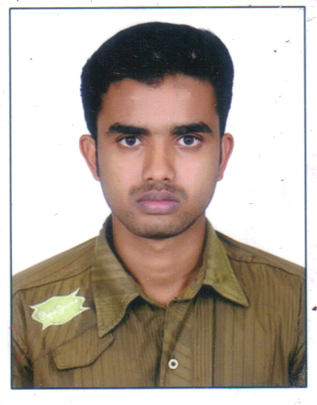  LITHIN  LITHIN.269793@2freemail.com  Personal Profile  Date of Birth – 14-7-1990  Age – 25  Gender – Male  Nationality – Indian  Marital Status – Single  Linguistic Abilities  - To Read and Write: Malayalam, English and Hindi  - To Speak Malayalam, Tamil, English, Hindi  My Strengths  - Leadership Qualities  - Self – Confident  - Patience  Project  “An exploratory study on MPEDA” | CAREER OBJECTIVE  To find an exciting and challenging career in a healthy environment where my education, experience and interpersonal abilities can be fully utilized.  ACADEMIC PROFILE  Post Graduate  2013 MIB (Master of International Business)  Dr. N.G.P. Arts and Science College,  Coimbatore.  Under Graduate  2011 B.com with computer application  Pilathara co-operative arts & science  College , Kannur  kerala  Percentage Secured :  Higher Secondary  2008 Government Higher secondary school,  Kaniyanchal ,Kannur , kerala  Percentage Secured :  SSLC  2006 N S S H S S Alakode , Kannur , kerala  Percentage Secured :  EXPERIENCE  - CURRENTLY WORKING IN ALRUQEE TRADING COMPANY AT KSA.  - WORKED AT NTA (CHA) FOR 9 MONTHS  - WORKED AT TRANSWORLD (CHA) FOR 1 YEAR AND 2 MONTHS.  JOB PROFILE  - IMPORT & EXPORT DOCUMENTATION.  - HANDLING OPRATION.  - HAVING COUSTOMS ‘H’ CARD.  EXTRACURRICULAR ACTIVITIES  - Computer skill ,Tally  Playing volleyball ,cricket,  COMPETENCIES  - Ability to deal with people Diplomatically  - Honest, Sincere with a high level of  Integrity & Good Communication Skills.  DECLARATION  I hereby declare that the information furnished above is true to the best of my knowledge.  Yoursfaithfully,

