RESUME
Emlin.269914@2freemail.com 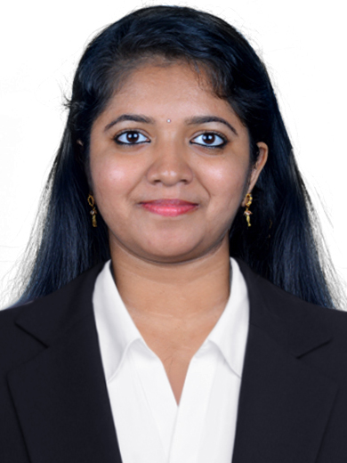
Emlin

Objective

Looking forward to work in a professional environment, which will enable me to develop my potentiality and efficiency, also to meet the challenges and excel in the field, where I can fully utilize my skills and knowledge.

Educational Qualification

MBA (Finance & International Business) Mahatma Gandhi University, Kerala – 2010

B Com (Commerce) Mahatma Gandhi University, Kerala – 2008

Plus Two (Commerce) Board of Higher Secondary, Kerala – 2005

Experience

Total Work Experience – 3.5 Years

Worked as an Accounts Associate in A Xerox Company Ltd, Kochi

Career Sketch

A Xerox Company Ltd, Kochi: December 2011- May 2015
Associate
(Reporting to Team Leader)
DEPARTMENT: Accounts Payable

MAJOR CLIENT: ATOS

- Accounts – Reporting and reminding the Accounts Department regarding the pending payments, over-exceeded periods of payments etc. to ensure un-interrupted supply from the suppliers.

- Handling all types of invoices which are completed within the allotted time
(Within SLA).

- Meet the target as per defined by process.

- Worked as an Associate in F&A Accounts Payable

- Hands on Experience in SAP and DART, Right Now

- Direct contact with Client in resolving issues

- Checking/Reviewing the work done by team members and helping them to correct the errors, if any.

- Handling Clients’ mails and giving response to them without any time delay

- Providing adequate support to the Team in all the activities/emergencies.

- Handling queries from different vendors.

Achievements

Trained Team members in Process and helps them to accomplish the targets.

Achieved best performer award for the last quarter.

Achieved Eagle Squad Award for the best performing Team.

Computer Skills

- Microsoft Office (Word, Excel, PowerPoint, Outlook)
- PGDCA

Strengths

- Can easily adapt to new and changing situations.
- Team Player.
- Positive Attitude

Hobbies

- Listening to music
- Cooking

Personal Information

Date of Birth : 28-01-1987

Gender : Female

Languages : English, Malayalam, Hindi

Nationality : Indian

Marital Status : Married

Reference

Will be provided on demand

Declaration

I hereby declare that the information furnished above is true to the best of my knowledge.

