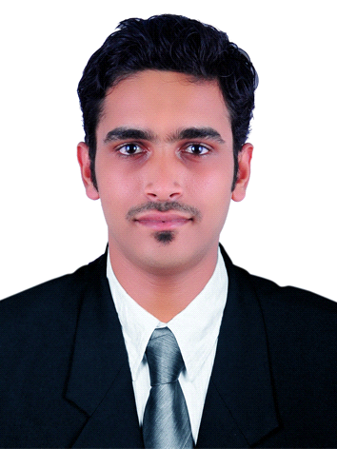
JISHAD
CIVIL ENGINEER
(QA/QC&QS IN CIVIL ENGG.)
Email: jishad.270312@2freemail.com
SKILLS & ABILITIES
Software known
- AutoCAD
- Ms Office
- Graphic designing with photoshop
STRENGTH
- Able to handle multiple tasks
- Effective communication skill, self motivated, confident and responsive
- Good team work
- Honest
- Adaptability
Achievements&Position held during academics
- Active participation in Arts festivals at school level and college level.
- Program Cordinator Dipartment Functions.

OBJECTIVES
I Cherish a demanding position that makes the effective use of my background. I would like to work in an environment where performance is rewarded with new responsibilities, and where mobility is the accepted norm.
PROFESSIONAL EXPERIENCE
COMPANY:HiLITE Builders Pvt. Ltd.
POSITION HELD :Civil Engineer
EXPERIENCE:Since 2014, April
2.0 year experience
PROJECT DETAILS
- Worked as part of an 8.2 million square feet construction project named HiLITE CITY, Calicut (Kerala, India) which includes
  - A shopping mall – HiLITE MALL
  - A commercial building – HiLITE BUSINESS PARK
  - Residential apartments – HiLITE RESIDENCY
- Worked as Site Engineer of a 22 storey residential building & A villa project Having 120 Villas in HiLITE CITY (structural, electrical, plumbing, interior, exterior and landscaping)
- Under took the landscaping works and completion of all common amenities.
NATURE OF DUTIES
- Preparing schedule of monthly activities as per the target
- Ensuring the work is going asper drawing with quality
- Organizing the day to day activities at site
- Ensuring labor strength and availability of materials
- Ensuring whether the execution is as per standards, specifications and cost effective.
- Ensuring the quality of work and safety at site
- Documentation and billing
- Assisting the officials in the various certification inspection by govt. authorities
- Discussions with Project Manager and General Manager about technical issues at site, discrepancies and problems in drawings, work schedules, etc.

EDUCATIONAL QUALIFICATION
 | Qualification | Board/University | Percentage
1. | QA/QC (NDT) & QS In Civil Engineering | Axion Institute of Civil Inspection, Calicut,Kerala, India | 85
2. | B.tech in Civil Engineering | Karnataka State open University(doing Fifth semester, Dist edu.) | 73
3. | Diploma in Civil Engineering (3 year) | Board Of Technical Examination Govt. Of Tamilnadu | 66.3
4. | Higher Secondary | Kerala State Educational Board | 76
5. | High School grad, SSLC | Kerala State Educational Board | 80

PERSONAL PROFILE
- Date of Birth : 10 – 05 - 1991
- Gender : Male
- Marital status : Single

Declaration
I, JISHad declare that the information furnished above is true to the best of my knowledge and belief.
Place;Calicut
date:03-03-2016 Jishad

