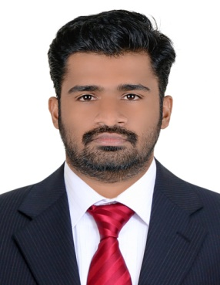

TELWIN
TELWIN.270920@2freemail.com
Career Objective:
To join a highly professional and dynamic organization where I can utilize my knowledge and vast work experience in the field of Electronics and Instrumentation Engineering to grab ample of career progression.
Professional Qualifications:
Course | Institution | Board/University | Year of passing | % of Marks
B.tech in Applied Electronics and Instrumentation | College of Engineering Trivandrum | Kerala university | 2015 | 65%
Diploma in Electronics and Instrumentation | Government polytechnic college ,Koratty | Board of Technical Education Kerala | 2010 | 68%
SSLC | Don Bosco HSS Irinjalakuda | Board of Public Examinations Kerala | 2006 | 78%

Professional skills and Strength:
- Highly motivated and goal oriented with commitment to deadlines.
- Innovative, Quick Learner, Efficient, Highly Motivated and Hard Working.
- Energetic and Focused team player.
- Good communication and interpersonal skills.
Software Skills:
- Operating System Windows Family , Ubuntu
- Languages C, C++
- Software’s MS office, Matlab,PLC & Labview Basics
Professional Work Experience:
Instrumentation Technician at Binani Zinc pvt ltd Cochin, Kerala.
Since: June 2010 to June 2012
Engineering Trainee at LNG Project at Cochin under Revelation Automation pvt ltd for one year

My responsibilities

- Installation, calibration, loops checking and commissioning of the field instruments. (Rosemount, Yokogawa, Masoneilan, Honeywell,ABB, Siemens).

Maintenance and Calibration of control valve :( Masoneilane, Fisher).Valve positioner Solenoid valve (Maxseal, Asco, Skinner)

- Maintenance and calibration of Level instruments: Displacer type (Masoneilan, Fisher),Float type, Hydrostatic Head type ,Level switch( Magnetron, Mercoid)

- Maintenance and Calibration of Temperature instruments: RTD, Thermocouple, Temperature switches and Thermo-probe

- Maintenance and Calibration of FLOW instruments: DPT (Yokogawa, Rosemount, ABB).

- Calibration of SMART instruments: HART Communicator 275, 375, 475(Rosemount).

- Trouble shooting, Open and closed loop checking.

- Calibration of Foundation Fieldbus instruments(METSO Positioner ND9000F,Rosemount

3051S).

Project & paper presentation.

SMART DUCT CRAWLER- academic project

INSTRUMENTATION IN HYDRO POWER GENERATION- seminar presentation

Courses Completed:

Two months Training in INDUSTRIAL INSTRUMENTATION from Nirmal Controls Thrissur.

Personal Interests:

Music, Films, Reading, Travelling, Playing.

Declaration:

I hereby declare that the information furnished above is true to the best of my knowledge.

