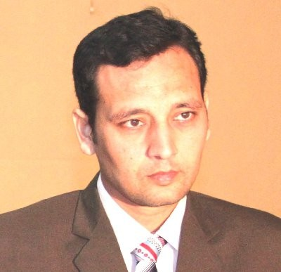Faisal

HIGH LIGHTS

• +10 years of experience in the field.
- Good problem solving skills with impressive personality.
- Self motivated, attitude of working as a team member and lead the team.
- Hardworking, Energetic, Honest and Sincere.

PERSONAL DATA:

Date of Birth: 21-04-1982
Email Address faisal.271166@2freemail.com
Visa Status: Visit

QUALIFICATION
Diploma Associate Engineer (Electrical) 1st. division PBTE Lahore

TECHNICAL SKILLS
- Installation, Testing, Breakdown Maintenance, Troubleshooting of all Electrical Facilities.
- Air conditioner installation repair and maintenance of all type.
- Transformers, power factor control panels, AC/DC breaking system
- Mov’s’ Actuators ,MCC circuit breaker, VCB, ACB, ABCB, BOCB Operating
- Experience in using all types of measuring equipment, AVO meters, AC as DC Clamp meters, Testing Meager, Electric Meter and Phase Sequence Meter, Taco meter.
- Installation and Operation of Low Voltage, Medium Voltage soft starters, medium and high frequency controllers (ABB-ACS 1000) Siemens, SEW and Mitsubishi.
- Split AC installation repair and maintenance work.

WORKING EXPERINCE:

Samsung C&T Corporation.
- STEP DTS T-01 (Strategic Tunnel Enhancement Program Deep Tunnel Sewer Contract T-01) Oct 06- 2011 –Jan 30 - 2015 Designation: Electrical Foreman.

Responsibilities:
- Preventive Maintenance and overhauling of motors, magnetic contactor and relays.
- Monthly and periodic inspection of Electrical Panels, Electrical Plants and other Electrical equipments.
- Installation of Motors, inverters and control panels.
- Experience of Erection Installation, Commissioning and Troubleshooting of Plants.
- Fault finding in faulty machines ,control circuits and rectify them
- To arrange the Electrical and PLC control panels.
- Installation, Maintenance and repairing all type of Frequency drive.
- Maintenance and Repairing H.T. Trolley.

- Calibration of monitoring and measuring sensors, Inverters, Programmable logic controllers
- Erecting Commissioning and Installation of CHINIES and H&B packers.
- Commissioning& Maintenance of MV Trolies, MCC Trolies, Frequency drive, Capacitor Panel, Soft Starter Panel, ABB Protection Relay, VCBs, MV Feeders, SF6 Breaker.

- Installation of LV Substation, Backfill Plants, Water Treatment Plants, Gantry Crane Control Panels, TBM Control Panels, Air Conditioners etc.
- Monthly and periodic inspection of Electrical Panels, Electrical Plants and other Electrical equipments.
- Installation of Motors, inverters and Control Panels during plant Erection.
- Fault finding in faulty machines, control circuits and rectify them.
- Arrangement of Electrical and PLC control panels.
- Installation, Maintenance and repairing all type of Frequency drive.
- Complete Installation of CCTV Cameras and DVRs, indoor and outdoor.
- Maintenance of communication lines, including Network and telephone cables.
- Preparation of Material Requisitions for Electrical requirements, follow ups with deliveries, and keep track of store inventory for consumable electrical items.

Textile Industry.

Kohinoor Textile Mills, Chakwal. Pakistan (3 Years)
  - ITHFZ Textile Mills, Sewabi. Pakistan (2 Years)
  - MTM Textile Mills, Faisalabad. Pakistan (2 Years)

Designation: Electrical Foreman. Responsibilities:
- Preventive Maintenance and overhauling of motors , magnetic contactor and relays
- Installation of Motors, inverters and control panels during plant Erection
- Experience of erection installation, commissioning and troubleshooting of Reiter Plant.
- Fault finding in faulty machines ,control circuits and rectify them
- To arrange the Electrical and PLC control panels.
- Installation, Maintenance and repairing all type of Frequency drive.
- Maintenance and Repairing H.T. Trolley.
- Work on Furnace Oil Boiler& adjust its fuel
- Calibration of monitoring, measuring sensors, Inverters, Programmable logic controllers
- Erection, commissioning and Installation of Cement Mill, Packing Plant, and 132KV Grid Station, Waste Heat Recovery Power Plant in Best Way Cement Ltd 5600TPD.
- Erecting Commissioning and Installation of CHINIES and H&B packers.
- Commissioning& Maintenance of Frequency drive, Capacitor Panel, Soft Starter Panel, ABB Protection Relay, VCBs, MV Feeders, SF6 Breaker, 25MVA, 40MVA Transformer & Transformer Protection relay.
16MW GAS Turbine & AVR Panel and commissioning.

*References can be furnished if required.

