**MOHAMED**

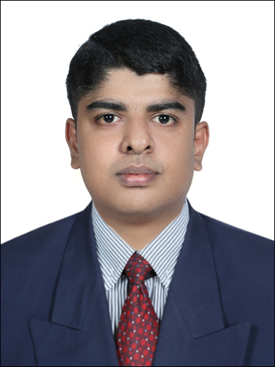

**Email :** [**Mohamed.271402@2freemail.com**](mailto:Mohamed.271402@2freemail.com)

**Personal Information:**

**Date of Birth : 03/03/1991**

**Gender : Male**

**Nationality : Indian**

**Marital Status : Single**

**Languages known : English, Tamil,**

**Malayalam**

**Place of Issue : Trichy, India.**

**Visa Status : Visit Visa**

**Driving License : India Only.**

Seeking a Career in an Organization With Potential Growth Prospects & Where I Can Offer Something in Terms of Skill & Knowledge to Achieve Organizational Goal.

**PROFESSIONAL EXPERIENCE :**

**Designation :** MEP Project Engineer

**Company Name:** VGN Infra India Pvt Ltd, Chennai.

**Duration:** May 2014 to October 2015

**Project Handled:**

* Baby Memmorial Hospital, Chennai (600TR)
* One Electrical Pump One Diesel Pump 2280 LPM & One Jockey Pump capacity of 180 LPM
* Vasu Co resort, vayalar chiller York (110TR)
* One Electrical Pump One Diesel Pump 1620 LPM & One Jockey Pump capacity of 180 LPM

**Jobs Responsibilities:**

* Executing the project.
* Site Meeting with consultants and clients.
* Time scheduling for projects.
* Quantity and cost estimation for the project.
* Preparation of monthly reports for projects.
* Co-ordinate with sub contractors.

Field of Study : **Mechanical Engineering** (76%)

Institute : M.I.E.T Engineering College, Trichy,

India.

University : AnnaUniversity, Chennai, India.

Passed Out : April 2014

**Technical Qualifications**

* Completed Professional **MEP in**  **HVAC, Fire Fighting and Plumbing** training program (2014) from **ACE India Training & Services PVT LTD, Kochi.**





**Software Proficiency :**

* MS OFFICE
* Auto CADD
* PROE & ANSYS
* REVIT
* HAP & McQuay ( Duct Sizer)

**Area of Interests :**

* In **SITE ENGINEER.**
* In **QUALITY CONTROL/ QUALITY ASSURANCE (QA/QC).**
* In **MEP** (Design,sales & marketing, planning, project etc.,)
* In **MAINTENANCE** and **TOTAL QUALITY MANAGEMENT.**

**PROJECTS /RESEARCH**

“**INCREASING THE BOILER EFFICIENCY BY USING WASTE HEAT RECOVERY SYSTEM**”

**INDUSTRIAL EXPOSURE:**

* Industrial visit to **“RANE ENGINE VALVE PRIVITE LIMITED”** Trichy for a day learnt about production of various engine valves, FMS system, Process Planning, TQM concepts, quality management.
* Participated in the workshop on “AUTOMOTIVE & ENGINE DESIGN at GOVERNMENT COLLEGE OF TECHNOLOGY, COIMBATORE.”

**TRAINING UNDERGONE**

**.**

|  |  |  |  |
| --- | --- | --- | --- |
| **Organization** | **Categories** | **Duration/Days** | **Training** |
| **AAVIN Trichirappalli Dist.Co-op.Milk Producers Union Ltd.** | Production | 30-days  (23/12/’13-23/01/’14) | About the refrigeration(**HVAC** basic),boiler operation, milk and ghee production |

**Date : Signature**

**Place :**