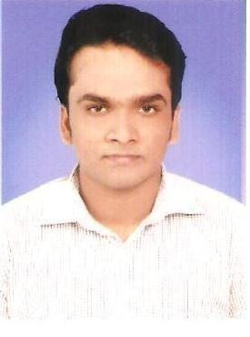
AFROZE
MECHANICAL ENGINEER
E-mail id: afroze.271418@2freemail.com
C/o-Mobile: +971 501685421

CAREER OBJECTIVE

To pursue a professional career and a challenging position in a competitive and progressive environment, where I can strive for excellence of my career as well as for the growth of organization.

QUALIFICATION

2015 Bachelor of Engineering (B.E) in Mechanical Engineering with Distinction from Visvesvaraya Technological University, Belgaum.

TECHNICAL SKILLS

- Trained in PROCESS PIPING ENGINEERING as per ASME B 31.3 with knowledge on the following,
- Codes and standards.
- Familiar with piping components, fittings.
- Process flow diagrams, utility flow diagrams, piping and instrumentation diagrams
- Development of plot plan.
- Development of piping layout, equipment layout.
- GA drawings, isometric drawings, GA to ISO conversion.
- Pipe supports and its selection criteria.
- Pipe rack load calculation.
- Various types of piping like compressor piping steam piping, utility piping, firefighting lines, vessel trims, flare piping, cooler piping, column piping.

SKILL SETS

Designing and Analysis Software

- Ansys Software (V 10)
- Solid Edge (V19)
- Plant Design Management System (PDMS)
- Process Piping Engineering (ASME B 31.3)

AREA OF INTEREST

- Automobile field
- Manufacture processing
- Piping field

WORK EXPERIENCE

Petrocon Engineers and Consultants, Mangalore, India
Design Engineer (September 2014 – August 2015)

Project : LPG Bottling Plant (HPCL Mangalore)
Client : HPCL (Hindustan Petroleum Corporation Limited)

Responsibilities:

- Updating of piping, equipment’s & nozzles elevation drawings as per site instructions using PDMS.
- Development of plot plan, overall layout and area division drawing.
- Development of P&ID, pipeline route layout, pipeline profile drawing, equipment layout & piping general arrangement drawings using PDMS.
- Preparation of manual isometric using PDMS with complete bill of materials as per specifications.
- Co-ordination with departments such as process, stress engineering mechanical, civil, instrumentation & electrical.
- Supporting site engineers at site in case of difficulties.

PERSONAL DETAILS

Date of Birth : 24-09-1993
Languages known : English, Hindi, Kannada, Malayalam and Basic Arabic
Nationality : Indian
Visa Status : UAE Tourist Visa

DECLARATION

I hereby declare that above information is correct to best of my knowledge and belief.

