RESUME

MOHD.271524@2freemail.com

MOHD

Marital Status:
Single

Languages Known:
English, Hindi & Urdu
Gender:

Male

Date of Birth:

09-10-1994
Objective
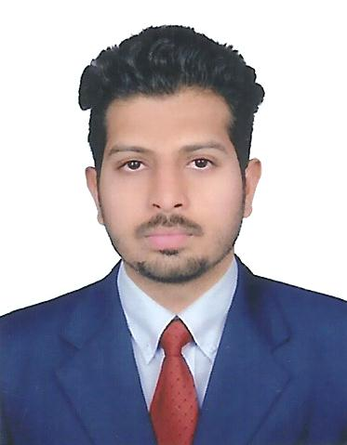
To join an organization with a healthy spirit of conquest with successful battling and overcoming difficulties with a sincere democratic approach. The only investment I want to make is my hard work in any environment, which I am sure, will fetch me the ability to work more intelligently and effectively.

Academic Records

- B.Com from Vidya Dayini Degree College
(Osmania University)
- Intermediate from Gowtham Junior College (C.E.C)
- S.S.C from St Mathews high School

Professional Experience
- Organization : Smart Agencies
- Designation : Junior Accountant
- Duration : June 2013 – August 2015
Roles and Responsibilities:
- Recording all transaction like purchases, sales, receipts, payment, contra and journal.
- Preparation of trial balance, profit & loss a/c and balance sheet with sources of funds, application of funds (working capital)
- Maintaining stock summary like item wise, group wise, categories wise and godown wise.
- Preparation of statutory reports as per govt rules like VAT, CST, TDS, & Service Tax.

- Preparation of salary statement using cost center and cost categories.

Nationality
Indian
Religion
Muslim

Passport Details:

Passport No: N2459367

Date of Issue: 04-09-2015

Date of Expiry:03/09/2025

Place of Issue: Hyderabad

- Familiar with purchase cycle (maintaining purchase order, receipt note, rejection out, purchase, purchase return/debit note)
- Familiar with sales cycle (maintaining sales order, delivery note, rejection in, sales, sales return/ credit note)
- Calculation of interest for debtors and creditors by using debit note / credit note.
- Maintaining of A/c book and statements of accounts for debtors and creditors with bill wise details.

Technical skills
- Operating System : 2000, XP, Vista, Win 7, 8
- Accounting Package : Tally ERP9.
- MS Office : 2003,2007(Word, Excel)
- MIS : Familiar With All Advance topics of
MS Excel 2007

Professional skills
- Comprehensive problem solving.
- Ability to work well with others.
- Willingness to learn new things.
- Delight in spontaneity.
- Reliability and trustworthiness,
- Competence and good judgment.

Area of Interest

- To Improving Interpersonal Skills
- To gain more knowledge of accounts and finance.
- Seeking a Position where I can work in a challenge environment.

Declaration

I hereby solemnly declare that all the above-furnished details are true to
the best of my knowledge and belief.

