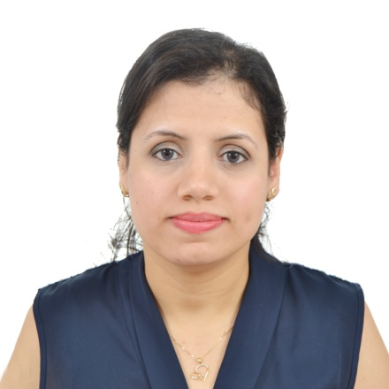
Jakleen

UAE. C/o 0501685421
jakleen.271697@2freemail.com
A highly talented and accomplished registered DHA Pharmacist with extensive skills and experience

Education:
- DHA license.
- Bachelor Degree of Pharmacy, Tanta University, Egypt, June 2011.

Objectives:
Seeking a career where my experience and qualifications can be enhanced and my career goals to be achieved and to build a long- term job in healthcare with opportunities for growth.

Professional work Experience:

Pharmacist in El Minshawy Hospital, Tanta , Egypt from Aug 2012 to Dec 2015
- Prepares medications by reviewing and interpreting physician orders; detecting therapeutic incompatibilities.
- Controls medications by monitoring drug therapies; advising interventions.
- Dispenses medications by compounding, packaging, and labeling pharmaceuticals.
- Maintains safe and clean working environment by complying with procedures, rules, and regulations.
- Maintains pharmacological knowledge by attending educational workshops.

Pharmacist in Masoud Pharmacy, Tanta, Egypt from August 2011 to July 2012
- Perform daily management of pharmacy, supervising all aspects of operations in absence of owner.
- Carry out inventory management.
- Take care of drug interaction.
- Provide customers and patients with information regarding prescriptions.

Computer and linguistics Abilities
- Knowledgeable with Microsoft Word, Excel and PowerPoint.
- Good command of spoken and written English.
- Native Arabic speaker.

Qualifications & skills:
- Ability to learn new tasks.
- Adaptable and can work effectively under pressure.
- Good time management and organizational skills.
- Ability to work as an effective team member.
- Solution oriented.

