Adeel
Adeel.272098@2freemail.com

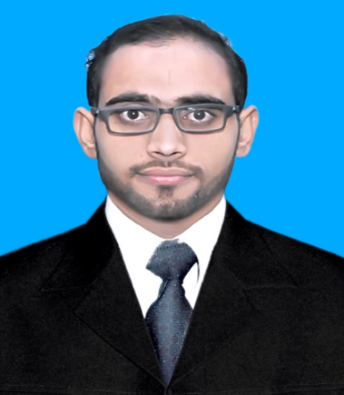
Mechanical Engineer
PEC No: MECHANICAL
Objective:
A fulltime-challenging job in Organization like yours where my creative talents and innovative capabilities will be best utilized.
Education:

Bsc Mechanical Engineering | Wah Engineering College Wahcantt | 2016
Higher Secondary School Certificate | Faran Model College Jhang | 2012
Secondary School Certificate | Govt. High School No.1 Pir Mahal | 2010
Experience:
- Process Dynamics Lahore (PDL) Fabrication and Erection Company, Pakistan
July 2016 to Present
- Worked as a Quality Engineer in different fabrication products like:
- Different product of 102 MW GulPur Hydro Power Project Kotli, like Lower Bend Profile Steel Structure, Steel Shuttering Form work and Coordinating with client team regarding improvements and modifications as per the site requirements.
- Fabrication of shuttering Structure and Roof Steel Structure Bus Station of Orange Line Train Project.
- Fabrication of Silo Tanks and Porta Cabin.
- Involve in planning and putting schedule for the execution of project as per drawings and standards.
- Involve in compliance of PPE’s, risk assessment, proper tool handling and permit to work system.
- Work on material handling and make inspection reports of the material as per the demand of the material.
- Make BOQ as per Drawing and Design requirement.
- Coordinate with designers of chienese client regarding technical issues in design and improvements and modification of the product as per site requirement.
- Working as a Site Engineer in Fabrication and Installation of a Bitumen Tank ID 9000mm in Project of KLM Section 3.
- Involve in planning with the Chinese client and contractors regarding improvement and quality as per site requirement.
- Pakistan Ordanance Factories (POF), Wah Cantt, Pakistan.
July-August 2015

- Visited different shops i.e Brass Mill, MAA Fy, SAA Fy, Services Group.
- Developed the understanding of basic machine shop operations, nondestructive testing, fabrication material testing and functions of PPC.

- Technical Interests:

- Willing to work in Turbo machinery like turbines, compressors, fans and pumps.
- Desire to work in manufacturing process.
- Interested in working of pipeline installation

- Personal Skills:
Fluent in written and spoken English. Honest, accurate, punctual and reliable. Excellent computer skills. Good team member and leader, excellent organizational, negotiation and networking skills. Able to work under pressure and deal multi-dimensional tasks with full efficiency and without keeping working hours in mind. Highly efficient in communication, liaison and coordination. Able to take any initiatives and work in diverse circumstances. Always willing to learn.
Personal Information:
Religion Islam
Nationality Pakistani
Gender Male
Marital Status Single
Date of Birth March 18, 1994.

