Curriculum Vital
Ijaz

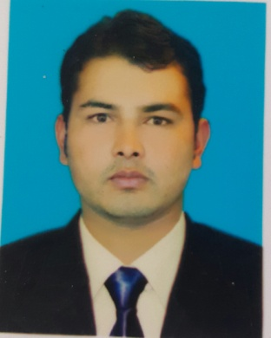
Work Experience: 18 Months (Related Field)
Email : Ijaz.272377@2freemail.com
Nationality : Pakistani
Date Of Birth: 08, March, 1990.

Vision &Objective
Looking for Challenging Career, Where there is scoop for demonstration always looks out for a positive and bigger outlook, to get an opportunity to improve my existing kills and to develop new ones by working as a part of talented people in a competitive and challenging environment.
Qualification
Degree/Diploma | Year | Institution
B.Tech (Electrical) | 2014 | SUIT(Sarhad University of Information technology) Peshawar
Diploma (Electrical) | 2009 | BTE(Board of Technical Education) Peshawar
B.A (Bachelor of Arts) | 2012 | University of Malakand
D.I.T (Diploma of Information Technology) | 2013 | TTB (Trade Testing Board) Peshawar
Safety supervisor | 2013-2014 | TTB (Trade Testing Board) Peshawar
Quality control | 2014 | TTB (Trade Testing Board) Peshawar
Work Experience
Muhammad Rashied Construction Company | Worked in Engineering department As Sub-Engineer (Electrical)  “From 06th, January, 2015 Till 28th, January,2016 “
Responsibilities:-
- Provides supervisor level oversight to the Distribution Control Center
- Monitors and directs switching activities and dispatches field resources
- Reliable service to the substations and sub-transmission and distribution systems
- Familiar with hydropower design issues, processes, projects, and initiatives.
Islamabad Electric Supply Company Limited (IESCO) | Worked in 132KV Grid Station Margalla As SSO-2 under Senior  “From 1st, November,2009 Till 30th, November, 2010.”
Responsibilities:-
- Reliable service to the substations and sub-transmission and distribution systems
- Familiar with hydropower design issues, processes, projects, and initiatives.

Computer Proficiencies
- AutoCAD
- Knowledge in Computers and Windows.
- MS-Word, MS-Excel, MS-PowerPoint.
- Internet Research
Other Skills
- Operations Management, Training, Quality Control, Client /Supplier Relations.
- Contractual Negotiations, Inter &Intra-departmental Liaison, Coordination Meetings &Drafting Summary.
- Supervision & Team Capacity Building.
- Interpersonal Skills, Time Management, Leadership & Analytical Skills.
- Optical Fiber cable jointing from SST Scientific skill training
- Security system on CCTV from SST Scientific skill training.
- Proficient in English, Hindi, Urdu & Pashto.

