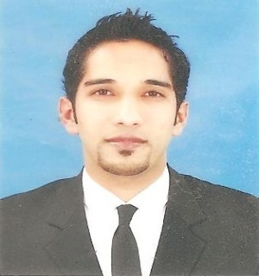 RANA

OBJECTIVE

Work with honesty, devotion and interest in a professional environment, an environment where I can have the opportunity to bring my knowledge and skills into use for the best interest of my employer and all the people who I interact, and keep on finding the ways to improve personal and organizational performance.

PERSONAL INFORMATION

Date of Birth: 14th April, 1984
Nationality: Pakistani
Sex / Marital Status: Male / Married

Religion Islam.

Current Residence Dubai, U.A.E

Email: rana.273556@2freemail.com

ACADEMIC QUALIFICATIONS

Degree | Institution | Year of passing
F.A | Jinnah Memorial College, Lahore Pakistan. | 2001
Matric | Govt High School Chuburji Lahore Pakistan | 1999
AutoCad | University of the Punjab, Lahore, Pakistan | 2007

WORK HISTORY

Sales Merchandiser (June, 2012 to till date)
Lenovo Computers Trading LLC Dubai.  (Innovation Direct Employment) | JobDescription  Lenovo Laptops and Tablets indoor selling at the floor  as a merchandiser.  (Plug Ins, Jumbo, Emax. Etc)

Salesman (Oct, 2010 to Feb,2012)
Whizz Computers Trading LLC  Bur Dubai.  (Wholesale Dealer) | JobDescription  Deals in all kind of IT products as well as Microsoft products.  Maintain Office and Store Record manually.  Work as Administrator.
Field Supervisor (Sep 2008, to March 2010)
Acme Services.  (U-fone vender)  Lahore, Pakistan | JobDescription  Wapda power supply, N.O.C (TMA)

Autocad Operator (Oct 2007, to Aug 2008)
JobDescription
Designing section especially to create a new design
with creativity and computerized environment
especially in CAD Technician is worth appreciation.
Working drawing also.

ACQUIRED SKILLS

- Excellent marketing, communication & interpersonal skills
- Negotiation, convincing & presentation skills
- Numeric and statistical skills
- Stress management skills to sustain pressure
- Ability to maintain efficiency and effectiveness
- Behavior management and observational skills
- Adaptable and flexible to work pattern

IT & COMPUTER SKILLS

Windows 7, Windows 8, MS Office (Word, Excel, Access) and Internet

INTERESTS
Reading books,Surfing internet, playing cricket, watching TV etc

