RESUME  RAMARAJAN  RAMARAJAN.273939@2freemail.com | 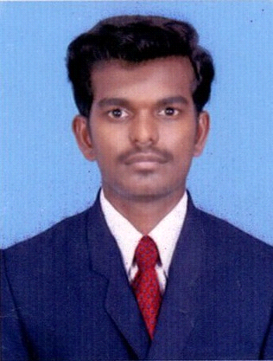
PROFESSIONAL SUMMARY:
Accomplished and energetic Supervisor with a solid history of achievement in installation of Solar modules. Motivated leader with strong organizational and prioritization abilities. Areas of expertise include hard working,honest,fast decision making.
ACADEMIC QUALIFICATION:
Degree | Year of  Passing | Institute | Board / University | % of Marks
B.E (Electrical and Electronics Engineering) | APRIL 2015 | LATHA MATHAVAN ENGG COLLEGE MADURAI. | Anna University  Chennai | 6.6 CGPA
Diplomo (Electrical and Elecitronics Engineering) | APRIL 2011 | RAMU SEEHA POLYTECHNIC COLLEGE KARIAPATTI-626106 | STATEBOARD TAMILNADU (ENGLISH) | 77%
HSC  SSLC (Xth Std.) | MARCH-2009  APRIL-2007 | T.U.N.S.V.Hr.Sec.School,  Thiruchli-626129.  T.U.N.S.V.Hr.Sec.School,  Thiruchli-626129. | STATEBOARD  (TAMIL)  STATEBOARD  (TAMIL) | 57.5%  79.6%
EXPERIENCE:

June 2016 to Present

Electrical Maintenance Engineer at BCJ Building Maintenance LLC
Dubai, United Arab Emirates.
Industry: Engineering Services. Company Size: 11-50 employees

October 2015 to March 2016

Supervisor at Giriraj 40MW Solar Power Plant
Virudhunagar, India.
Industry: Energy and Utilities, Engineering Services, Engineering Services
Company Size: 51-100 employees

May 2015 to Oct 2015

HOD & Lecturer at Sree Vari Mayasudhan College of Polytechnic
Ramanathapuram,Tamilnadu, India.
Industry: Education. Company Size: 11-50 employees

May 2011 to Jun 2012

Lab Instructor at Ramu Seetha Polytechnic College
Virudhunagar, India.
Industry: Education. Company Size: 51-100 employees

COMPUTER SKILLS:

Operating Systems : Window-XP, Windows-7,Windows-8.
Software known : E-CAD,PLC,MATLAB,AUTOCAD.
Software Packages : MS-Office , C,C++,JAVA
AREA OF INTEREST:

- Electrical machines
- Power system
- Electrical Estimation

PERSONAL SKILLS:

- Adopt to new environment
- Ability to organize a team
- Established capability to follow procedures and guidelines

PERSONAL PROFILE:
Date of Birth : 05-06-1992
Age : 25
Gender : Male
Nationality : Indian
Religion : Hindu
Marital Status : Single
Languages Known :Tamil,English&Hindhi
Driving License :Light vechicle with Batch Issued by India.
Diplomo Project Name :Advance Load Sharing System For Appartments
BE Project Name :Design And Development of Multifunctional Energy Meter

DECLARATION:

I hereby declare that all the information provided by me in this application is factual and correct to the best of my knowledge and belief.

Place: Signature

