CURRICULUM VITAE
Name: FUHROGER
Marital Status: Single
Date of Birth: 19th July, 1987
Place of Birth:Nkwen - Cameroon
Nationality: Cameroonian
Resident: United Arab Emirates
E-mail: fuhroger.274419@2freemail.com
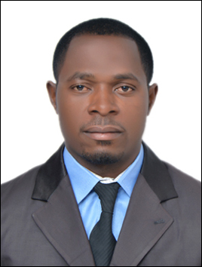

Academic Background
- 2012 – 2015: Masters in Immunology and Microbiology, Catholic University of Central Africa, Yaoundé
- 2006–2010: Bachelors of Sciences in Animal Biology, University of Yaoundé I.
- 2006: GCE Advanced Level, Progressive Comprehensive College Bamenda.
- 2004: GCE Ordinary Level, Progressive Comprehensive College Bamenda.
Teaching Experience
- 2011 – 2012: Biology Teacher at ‘La Gaite’ International School Complex.
- 2012 – 2016 : Biology and Chemistry teacher at Government Bilingual High School Mendong – Yaounde
Key Responsibilities
- Biology Teacher, Lower and Upper sixth classes.
- Chemistry Teacher of Form 3 and Form 4.
- Head of Biology Laboratory.
- Class master of Form 4.
- General Certificate of Education examiner.

Trainings
- Training on Project writing and Management of enterprise.
- Training on Administrative techniques and respect of hierarchy.
- Training workshop on Reproductive Health and Sexual Health Safety and Management.
Computer Training Computer Skills
Word processor: Microsoft word 2003, Microsoft word 2007, 2010, Open Office.
Spread sheet: Microsoft Excel 2003, Microsoft Excel 2007, 2010.
Operating Systems: Windows 2000, Windows XP,Windows Vista, Windows 7. Internet & e-mail: Microsoft outlook 2003, 2010.
Presentation: Microsoft PowerPoint 2003, Microsoft PowerPoint 2007, 2010.
Highlights of Skills
- Proven leadership aptitude with over 6 years of experience at University and other Organisations, Program/Project Management as well as conference organisation. Areas of interest include clinical trials, capacity building.
- Exceptional Marketing & Sales skills with outstanding ability to communicate in a sensitive and courteous manner with various target audiences.
- Excellent interpersonal talents with demonstrated ability to work with multicultural environment.
- Capable of working independently or as a productive team member with outstanding time management, analytical and problem solving skills.
- Very organized and detail oriented with an understanding of Knowledge Management concepts as well as a proven ability to maintain confidential information.
- Bilingual: Fluent in English and French with proficient computer skills in both languages.
Language Skills
Working Languages Speaking Reading Writing
English Advanced Advanced Advanced
French Advanced Advanced Good
Personality: Respectful, commitment in service and a team spirit.

