Nadia  Nadia.274533@2freemail.com | 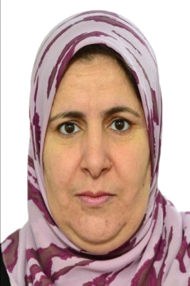

Profile
Accomplished, motivated and versatile Estimator Steel detailer& Quantity Surveyor experienced Project with around 16+ years of experience in the Construction industry, known for a personable approach to clients and co-workers as well as for delivering and implementing advanced contractual solutions to medium and Large-size Projects.
Seeking a demanding position as Civil Engineer to utilize my development skills and contribute to the company's growth
*Experience
Nov2000 to Present, BATICIM (Ain oulmene) Algeria
Technical Department
Steel Detailed Estimator Autocad designer and Quantity Surveyor.
Duties & Responsibilities:
· Successfully providing commercial supports for the Post Contract Quantity Surveying Team on Structural, Steel structure
· Managed and evaluated change orders and compliance of cost implications
· Quantity
· BOQ Preparation
· Review documents
· Steel detailer, draw plans, make detailed tracing , calculates the amount and length of the steel structure
· Overall Project Estimation
· Calculation of Steel Structural requirement
· Reviewing Project Status by lessoning with Client.
· Quantity take off – All Structural Accessories
· Study of drawings and Prepare BOQ in MS-Excel format
· Draw plans, make detailed tracing.
- From 15/03/1995 to 15/12/1995 to BATICIM (Company of Construction of Industrialized Metal structures) like higher technician in technical Department.
-January 1999: Private technical office (ARCHITIME) in Setif like designer.
-January-November 2000: Private technical office in Setif like designer and secretary.

PROJECTS ATTENDED
* Pylons for electric power transmission lattice – Building & Structural Section
* Catenaries poles for the electrification of the rail network – Structural Section
* Masts and Towers freestanding guyed and intended for telecommunication networks,- Civil Section
* Billboards – MEP Section
* Various metal products Metal joinery, carpentry stations for electric power transformer, Armaments and tile, - Structural & Civil Section
* Industrialized Buildings, framing and storage sheds – Building Section

Education
*1989-1993: University Ferhat Abbas Setif ALGERIA
DEUA (diploma of applied university studies in civil engineering option metal construction)
* July 1989 Technical baccalaureate (Public works).
* 1985-1989: New technical college of setif ALGERIA
Computer Knowledge
Auto Cad – 2013
Sketch up – 2013
MS Office & Adobe Acrobat

PERSONAL DETAILS

Date of Birth : 12th Oct1968
Gender : Female
Marital Status : Single
Languages Known:
* Arabic (Native Language),
*French (Second Language)
*English

