First Name of Application CV No 1647432
Whatsapp Mobile: +971504753686
To get contact details of this candidate Purchase our CV Database Access on this link.
http://www.gulfjobseeker.com/employer/services/buycvdatabase.php

JOB OBJECTIVE
Seeking Challenging assignments in Management/ General Administration, preferably in UAE/Middle East

SUMMARY
- Nearly 3 years and 6 months of success as Regional Manager, Resource Management, General Administration, Sales and Marketing, Team Leader, Employee Relations / Welfare, and Coordination & Liaison Functions
- Ability to conceptualise and effectuate measures so as to optimise resource and manpower utilisation
- Ability to research, identify, and develop relationship with clients
- Ability to gain a clear understanding of businesses and requirements and work

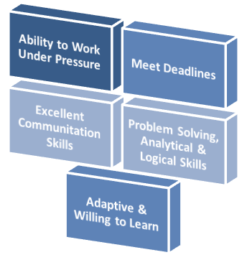 | 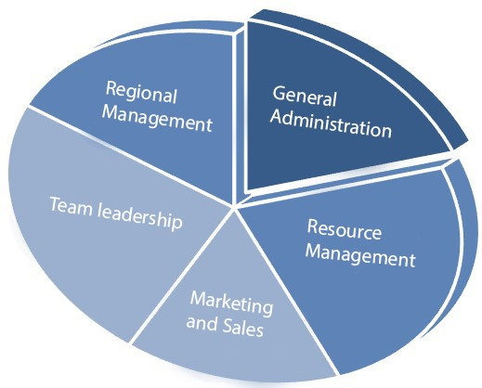

ORGANIZATIONAL EXPERIENCE

- Resource Manager at TEMPT CREATIONS, INDIA from 15/01/2012 to 10/07/2014.
- Research, identify, and develop relationship with clients.
- Ensures the development and implementation of campaign strategies to meet financial resource potential.
- Works with the Marketing and Communications team on all marketing and media efforts, including material and message development.

- Regional Manager at SUCCESS POINT TRAINING SOLUTIONS, INDIA from 21/07/2014 to 25/07/2015.
- Heading the region and developing and managing business plans.
- Maintaining and developing relationships with existing clients in person and via telephone calls and emails.
- Acting as a contact between a company and its existing and potential markets.
- Gaining a clear understanding of businesses and requirements.
- Maintains professional and technical knowledge by attending educational workshops.

EDUCATION
Course | Specialization/Subject | University/Board | Institution Name | Year of pass | % of marks
Advanced certificate course | NDT Level II  (RT,MT,UT,PT) | ASNT Certified | KELTRON, Trivandrum | 2015 | 86,87,  88,86
Advanced certificate course | Piping Engineering | ASNT Certified | KELTRON, Trivandrum | 2015
Advanced certificate course | Welding Inspection | ASNT Certified | KELTRON, Trivandrum | 2015
B-Tech | Computer Science | Kerala university | Lourdes Matha College of Science and Technology, Trivandrum | 2014
12th | Computer Science | CBSE | Abdul Salam Rafi Residential Public School, Trivandrum | 2010 | 65
10th | General Subjects | CBSE | Abdul Salam Rafi Residential Public School, Trivandrum | 2008 | 80

TECHNICAL EXPERTISE
QA/QC | NDT, PIPING, WELDING
Programming Languages | C, C++, Basic Java
Operating system | Windows 98,XP,7,8,10
Application Package | MS Office(PowerPoint, Word, Excel), Adobe Photoshop, FL Studio
Skills | Non-Destructive Testing, Hardware assembly, Image editing

ACADEMIC PROJECTS
MAIN PROJECT: H-Automate-Home Automation System
This paper presents the overall design of Home Automation System (HAS) with low cost and wireless remote control to assist and provide support to fulfil the needs of elderly and disabled in home. The main control system implements wireless technology to provide remote access from PC/laptop/smart phone.

MINI PROJECT: Student Database Manager
Developed a user friendly and time saving software tool to manage student database. The software tool consists of options to manage the student’s details by updating the information and analysing the data as well as providing results for the analysis. Proper authentication is also provided for both the software students.

SEMINARS AND PRESENTATION
SEMINAR TOPIC: Hand gesture recognition using shape parameters.
This seminar presented at college level which was part of my S7 curriculum deals with a real time system for hand gesture recognition on the basis of detection of some meaningful shape based features. Visually impaired people can make use of hand gestures for writing text on electronic documents like MS Office, Notepad etc.

POSITIONS HELD
Singer and Manager of musical band from South India, named ADDICTION THEORY.
House Captain and Students representative at school.

HOBBIES AND INTERESTS
Automobiles, computing, martial arts, singing, gym, travelling, watching movies, football.

PERSONAL DETAILS
Date of Birth : 01st Dec, 1992
Nationality : Indian
Marital Status : Single
Linguistic Abilities : English, Hindi, Malayalam and Tamil

