Curriculum Vitae
SAYEED  Present Residence :- Ajman U.A.E  Nationality :- Indian  Willing to work industry :-Accounting or Administration & Finance | 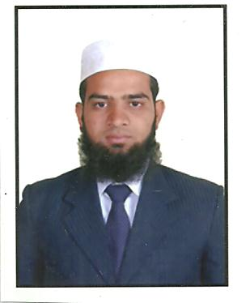

Objectives:
To work in an esteemed organization where I can prove my technical and functional expertise and work towards the growth of the organization and to seek a challenging career in cutting edge technologies.

Education:

Qualification : M.B.A (Finance)

From Osmania University in June (2008) Hyderabad,India.

: Bachelor of Commerce (Computers)

From Osmania University in April (2006)
Hyderabad,India.

: Intermediate (CEC)
From Board of Intermediate in (2002) Hyderabad,India.

S.S.C
From Board of Secondary Education in (2000) Hyderabad,India

Software Skills:
Accounting Packages : Tally ERP9. Focus, Wings & Peachtree Software Packages : Microsoft Office (MS-Word, MS-Excel, MS-Power Point).

Gulf Experience
- Worked as an Accountant General in Al Tareeq Feeds Trd.Co .L.L.C. Al Dhaid, Sharjah ,U.A.E. From February 2014 till Sept 2019.
- Worked as an Accountant in a Real Estate Company based in AJMAN, U.A.E. From October 2019 to Feb 2020.

Indian Experience:
- Worked as an Accountant in Fire Cool Engineers, Abids ,Hyderabad. India From August-2008 to December 2011.
- Worked as an Accounts Manager in J.B. Group,New Aghapura,Hyderabad. India From January -2012 to November 2012.
- Worked as an Sr.Accountant in Amego Paints & Hardware,Humayun Nagar,Hyderabad. India From December -2012 to December 2013.

Strengths & job Responsibilities
Strengths
- Ability to work in-group as well as independently with minimal supervision.
- Talented & Ready to face new challenges with adding new Improvements.
Job Responsibilities
- Responsible for Accounts management for the company.
- Maintaining General Ledgers, Accounts Receivable & Payable records.
- Operating financial accounting software Tally ERP 9.0. & MS EXCELL.
- Maintaining Accounts for Inventory system.
- Perform the Bank Reconciliation & entire transaction held in Company.
- Passing necessary rectification entries.
- Computing of Value Added Tax (Vat) of U.A.E & Online Submission.
- Creating Trading & P&L A/c and Balance Sheet.
- Maintaining of financial accounts & submitting to Auditor.

Achievements:

- Consistent performance despite facing odd situations.
- Garnered valuable knowledge at every stage of professional life.

Skills:
- Good Command over English, Urdu, Arabic & Hindi.
- Knowledge of Internet & Posses typing Speed of 35 words per min.
- Excellent Interpersonal & Soft Skills.

Personal Profile:
Date of Birth : 15-July-1985.
Marital Status : Married
Nationality : Indian
Driving License : U.A.E (Light Vehicle)
(Issued on 06-12-2015)
CONTACT DETAILS
Contact Email : sayeed-274945@2freemail.com
Reference : Mr. Anup P Bhatia, Market Research HR & IT Consultant
Mobile No. : +971504973598

Disclaimer: I assert you that the information furnished above are relevant to my knowledge.
(SAYEED)

