First Name of Application CV No 1662438
Whatsapp Mobile: +971504753686
To get contact details of this candidate Purchase our CV Database Access on this link.
http://www.gulfjobseeker.com/employer/services/buycvdatabase.php

OBJECTIVE

To acquire any position requiring innovative, challenging employment that will utilize my educational and professional skills and can offer advancement.

QUALIFICATION

Master of Arts in Secondary Education- Graduate
Major in Social Studies

Bachelor of Secondary Education- Graduate
Major in Social Studies

Research Presenter
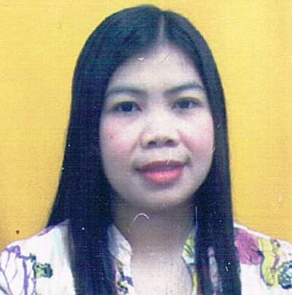
PROFILE & KEY SKILLS

- Knowledgeable of MS Office (Word, Excel, Powerpoint)
- Able to work on own initiative with less supervision or within a team environment
- Courteous and respectful in dealing with colleagues
- Proficient in oral and written communication in English Language
- Punctual, methodical ,accurate and systematic
- Able to work under pressure and flexible
- Creative and artistic

WORK EXPERIENCE

June 2012-2016- Social Science College Instructor
De La Salle Lipa
Lipa City, Philippines

June 2010 Research Assistant
University of Batangas Philippines
Center for Research Publication and Extension.
April 2009-2010 First Year Social Studies Teacher
Saint Bridget College Batangas Philippines
May 2011-2012 Social Studies Teacher
Batangas State University
Batangas Philippines

EDUCATIONAL BACKGROUND

Master of Arts in Secondary Education- GRADUATE

Bachelor of Secondary Education (2009)- GRADUATE
University of Batangas, Philippines

PERSONAL INFORMATION

Nickname : Jaja
Birthday : July 23 1985
Age : 30
Status : Single
Nationality : Filipino
Language Spoken/written : English, Filipino
Interest : Dealing with others
Visa Status : Tourist Visa

SEMINAR

September 24, 2008 University Of Batangas Auditorium
Facilitating Active Learning
May 20, 2009 Saint Bridget College Batangas
Enhancing Table of Specification
May 18, 2013 UPLB- Laguna
Research Methods and Application

April 20, 2014 Laguna College of Business and Arts
Research Forum

September 20-21,2015 Promotion of Global Education and Students’ Global
Perspective in Social Studies
Century Park Hotel Manila
Research Presenter

Dec 16-18, 2015 Promotion of Global Education and Students’ Global
Perspective in Social Studies
HKCEPS Hongkong- Research Presenter

