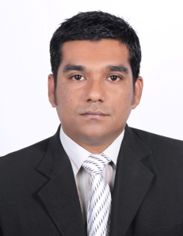

KHALID
Khalid.277469@2freemail.com

OBJECTIVES
Maximum use of abilities and effective performance of responsibilities that leads towards optimal achievement

EDUCATIONAL BACKGROUND

- MBA (Finance) 2013
- Hamdard University
- Karachi, Pakistan

- BBA(Hons) 2008
- Indus University
- Karachi, Pakistan
- 2.97 CGPA

EXPERIENCE
- Shaheed Benazir Bhutto University
- Nawabshah Pakistan
- Designation: Accountant
- Tenure: Feb 2015 Till date

AMRDO Micro Finance
- Nawabshah Pakistan
- Designation: Accountant
- Tenure: Jan 2014- Aug 2014

GemNet (Pvt.) Limited
- Karachi- Pakistan
- Designation: Finance executive
- Tenure: Jan 2013- Dec 2013

HM Indus Accountants and consultants
- Karachi- Pakistan
- Designation: Accounts Trainee
- Tenure: Jul 2012- Dec 2012

Z.Lakhani& Co. Chartered Accountants
- Karachi- Pakistan
- Designation: Accounts Trainee
- Tenure: Jan 2012- Jun 2012.

COMPUTER SKILLS

- Six Month Course Of C.I.T
- MS Office (MS Word, MS Excel, MS Power Point)
- MS Outlook
- Internet Application
- Accounting software Quick Books- Accountant Edition.

PERSONAL PROFILES

- Good at Presentation, Documentation and Communication
- Able to work under pressure and meet deadlines.
- Familiar how to work with a team.
- Strong Analytical Skills/Speaking English.
EXTRA CURRICULAR ACTIVITIES

- Surfing Internet, Reading Islamic books, Research books & magazines, Playing Cricket & Hockey.

REFRENCE

- Will be provided on request if required.

