JENIBA

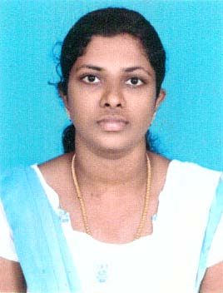

Nationality : Indian
Date of Birth: 30/06/1991
Marital Status: Married

Visa status :Residence

Key Skills
Get involve with children easily
Extrovert
Good teaching skill
Explaining Power
Fast Learner

IT Skills
MS-Office
C&C++
Extensive knowledge of Internet

Languages Known
English – Fluent
Tamil - Fluent
Malayalam – Fluent

Interests
Interaction with Children
Teaching
Singing
JENIBA.277576@2freemail.com
As a teacher, I would like to utilize my lively and energetic
attitude in teaching student with great enthusiasm and to obtain a
teaching position that uses modern teaching methods such as e-learning
and team learning.

CAREER FOCUS: Teacher
Experience: 1 Year 6 Months
Academic Qualifications:
B.Ed. – Bethlehem College of Education, Tamil Nadu in 2012
M.Sc. Physics- Nesamony Memorial Christian College ,Tamil Nadu in
2016
B.Sc. Physics- Scott Christian College, Tamil Nadu in 2011
Strengths:
Verbal and communication skills
Honest
Strict when required
Skills:
- Excellent communication skills, good knowledge of the teaching
principles and methods of teaching.
- Ability to prepare lesson plan to the students.
- Ability to grade the exam papers, maintain the records.
- Ability to manage the classroom.
- Lenient in handling the children
- Ability to utilize advanced methods of teaching.
- Knowledge of student psychology.
- Teaching the innovative subject of Science through an
experiment.

Career Accountabilities:
SREE Ramakrishna Matriculation Higher Secondary School- India
Teacher
Responsibilities:
- Responsible for handling a class of 40 students.
- Applying innovative interactive methods to make learning fun.
- Initiate in organizing quiz and workshops in collaboration with
students.
- Conducting group activities.
- Preparing lesson plan for the students.
- Discussing the progress of the students with their parents.
- Planning and preparing teaching methodologies for the students.

Declaration:
I hereby declare that all the information furnished above are true to the best of my knowledge
and no information or details have been intentionally hidden, and I am fully aware of the fact
that my selection is purely based on the genuineness of the above information.

