**DOB:** 30.10.1980

**Nationality**: Indian

**Language proficiency**: English, Hindi

A seasoned dermatology and cosmetology professional with 6 years+ experience after Post Graduation in reputed colleges and hospitals in India. Looking for a dermatologist job in leading hospital/clinics in Dubai.

Educational Qualifications

**M.D. (Masters in Dermatology Venereology and Leprosy)**

2005-2008

Lady Hardinge Medical College, India.

**M.B.B.S.**

1999-2004

Lady Hardinge Medical College, India.

Professional Experience`

**January 2014 to March 2015**

*Specialist Dermatologist*

*Aster Aesthetic Center*

*Dubai, UAE*

**Job profile:**

* Imparting Aesthetic and dermatological care to the patient. Use of minimally invasive cosmetology and dermatology procedures, including botox and most of the types of ablative and non-ablative lasers.

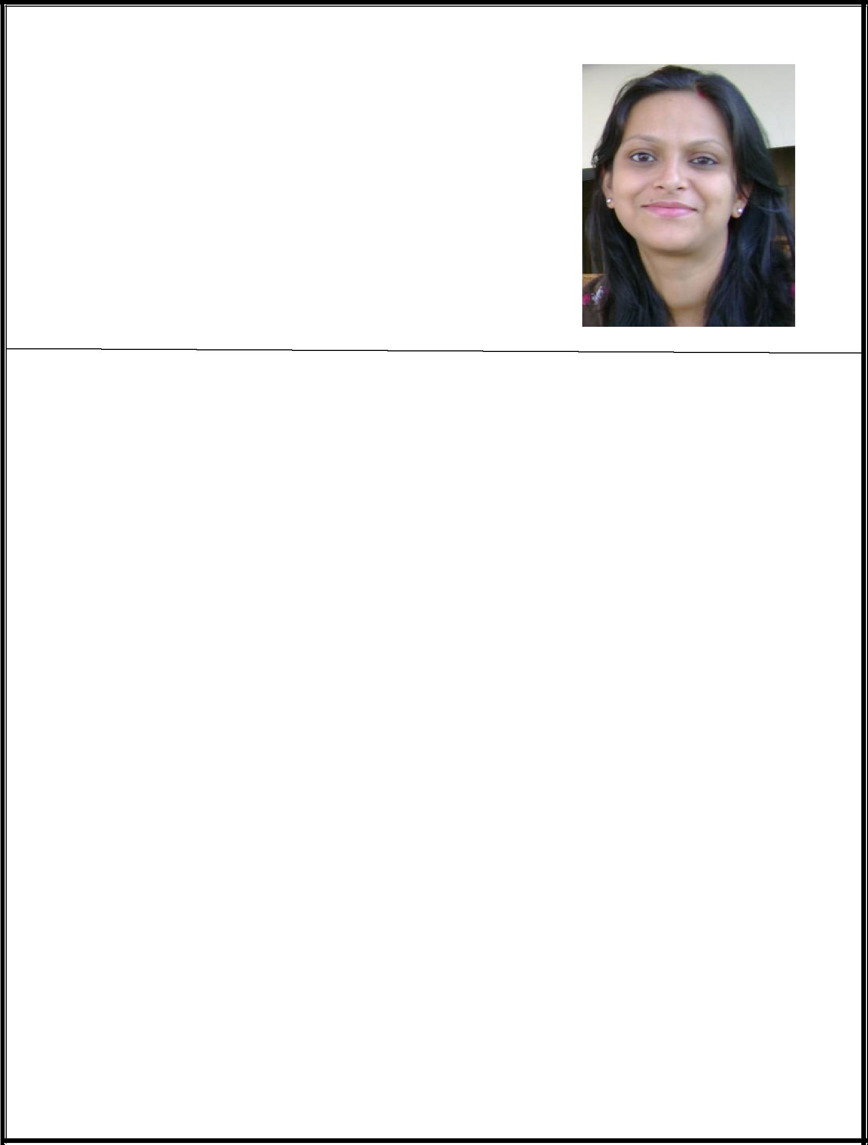**January 2013 to January 2014:**

*Consultant dermatologist and cosmetologist*

*Artemis Hospital (JCI accredited)*

*India.*

**Job profile:**

* Outpatient and inpatient care of patients with dermatological and cosmetological complains, comprising of consultation, medication and necessary follow-ups for dermatology and sexually transmitted diseases.
* Use of minimally invasive cosmetology and dermatology procedures, including botox and most of the types of ablative and non-ablative lasers.

**October 2011 to December 2012:**

*Consultant dermatologist and cosmetologist*

*AA center for skin and cosmetic surgery*

*India.*

**Job profile:**

* Outpatient and inpatient care of patients with dermatological and cosmetological complains, comprising of consultation, medication and necessary follow-ups for dermatology and sexually transmitted diseases.
* Use of minimally invasive cosmetology and dermatology procedures, including botox and most of the types of ablative and non-ablative lasers.

**September 2008 to September 2011:**

*Senior Resident*

*Lady Hardinge Medical College*

*India*

**Job profile:**

* Holistic care of patients with dermatological complains, including outpatient, inpatient and emergency services, for dermatology and sexually transmitted diseases.
* Planning and execution of inter and intra departmental clinical trials and case studies and assisting the senior faculty with the same.
* Curriculum based teaching of basic dermatology to postgraduate and undergraduate students, with in-class lectures and practical on-patient case discussions, in OPD and inpatient setup.

**Thesis**

Contact dermatitis in nurses and paramedical staff: a study of clinical profile and patch testing. (Study Duration: January 2006- December 2006)

**Awards and Achievements**

Prof B N Banerjee Medal for Best Original work titled **“**Contact dermatitis in nurses and paramedical staff: a study of clinical profile and patch testing.” at national conference DERMACON, 2008

**Paper Presentations**

* “Innovative use of an old remedy to induce quick repigmentation in vitiligo” Annual Conference of Indian association of Dermatologist, 2011
* “Role of anti IgE in Dermatology” International Medical Science academy, Delhi

chapter, 2010.

* “Histoid Hansens: A 9 year clinic-epidemiological study” Award paper, The 27th

Biennial Conference of Indian Association of Leprologist’s, 2009.

* “Childhood leprosy: Is leprosy really eliminated?” The 27th Biennial Conference

of Indian Association of Leprologist’s, 2009

* “Contact dermatitis in nurses and paramedical staff: a study of clinical profile and patch

testing” Young Dermatologist Session, Annual conference of Indian association of

dermatologist, 2007.

* “Phaeohyphomycoses due to Exophiala spinifera” CME, 2006.
* “Incontinentia Pigmenti: A typical Presentation” CME, 2005.

**First Name of Application CV No:** **1668960**

Whatsapp Mobile: +971504753686

