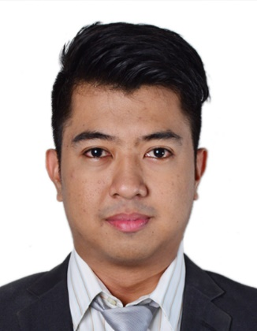
CURRICULUM VITAE

E-MAIL
Emilson.278502@2freemail.com

DATE OF BIRTH

May 28, 1986

NATIONALITY

Pilipino

LANGUAGES

English
Filipino

IT SKILLS

MS Office Suite
SPSS
Photo/Video Editing
Adobe Authorware
Web Browser
Basic PC Troubleshooting
Android OS Troubleshooting

OTHER SKILLS

Counseling
Photography
Handling Confidential Matters
Analytical Skills
Interpersonal Skills
Human Resource Background

Emilson

EDUCATION

2010-2015 The National Teachers College Manila, Philippines

Master of Arts in Education Major in Guidance and Counseling
(Academic Requirements Completed)

2004-2008 Colegio de San Juan de Letran Calamba, Philippines

Bachelor of Science in Psychology

PROFESSIONAL EXPERIENCE

2009-2015 Colegio San Agustin – Biñan Laguna, Philippines
Testing Officer
                - Coordinates the psychological testing requirements of the department and helps in the full implementation of the services of the guidance and testing center.
                - One of the key person responsible for hiring and recruiting academic and non-academic personnel.
                - Responsible for a wide range of statistical and psychometric activities related to test construction, validity, reliability, standard setting, analysis and scoring of battery of different examinations.
                - Develops and implemented the computerized entrance test base on the school standard.
                - Develops test-related researches and executes statistical analysis on different test administered and keeps a systematic and updated test profiles.
                - Conducts Annual Career Planning/Counseling to students based on the students’ test scores and personality.
                - Involvement in the academic personnel appraisal system.

2008-2009 Colegio de San Juan de Letran Laguna, Philippines
Administrative Assistant
                - Types correspondence, reports and other documents.
                - Coordinates repairs to office equipment.
                - Maintains confidential records.
                - Researches and assists with the preparation of motions, policies and procedures
                - Reviews and edits reports to the Board
                - Prepares agenda for Board meeting

OTHER EXPERIENCE

                - Volunteer at the Autism Society of the Philippines-Laguna Chapter.
                - Performs Counseling Outreach to the children in an orphanage.
                - Performs Counseling Outreach to the less fortunate children in a public school.
                - Conducts psychological testing and counseling to the abandoned children in an orphanage.
                - Works as photographer during social events and gathering.
                - Held the position of photography club adviser.
                - Conducts Team Building/Leadership Seminar to aspiring young student leaders.

