First Name of Application CV No 1681230
Whatsapp Mobile: +971504753686
To get contact details of this candidate Purchase our CV Database Access on this link.
http://www.gulfjobseeker.com/employer/services/buycvdatabase.php

Respected Sir / Madam,
I have more than 15 Years Teaching Experience in Pakistan and UAE. I take every student as a Challenge. With this experience as a primary/Middle Mathematics teacher, I am adept in classroom instructions, development of institute plans and parent Teacher relations. Moreover while my on the job experience has afforded me a well-rounded skill set including first one rate conflict resolution and problem solving abilities.
I also have a solid education foundation and a passion for Teaching. I am extremely enthusiastic to join your Institution and would welcome the Opportunity to countable to improve your students.

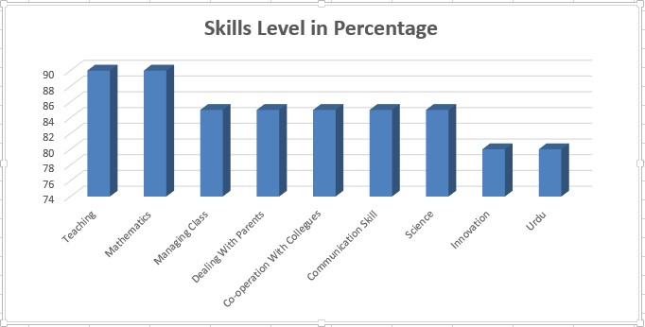

Teacher (Mathematics/Science/Urdu)
Objective : To seek a challenging position in professional and dynamic organization with an aim to contribute towards the objectives of the organization and simultaneously develop professional skills.
Education
- Bechelor Of Education(Al Khair University)
- Graduation B.Sc(Double Maths,Physics) Zakaryia University
- Intermediate (Multan Education Board)
Employment History
Mathematics Teacher |  | New Indian Model School Dubai | Sepyember2014 ~ Till Now
Responsibilities & Duties :
- preparing and delivering lessons to a range of classes of different ages and abilities;
- marking work, giving appropriate feedback and maintaining records of pupils' progress and development;
- researching new topic areas, maintaining up-to-date subject knowledge, and devising and writing new curriculum materials;
- preparing pupils for qualifications and external examinations;
- managing pupil behaviour in the classroom and on school premises, and applying appropriate and effective measures in cases of misbehaviour;
- communicating with parents and carers over pupils' progress and participating in departmental meetings, parents' evenings and whole school training events;
- liaising with other professionals, such as learning mentors, careers advisers, educational psychologists and education welfare officers;
- supervising and supporting the work of teaching assistants, trainee teachers and newly qualified teachers (NQTs);
- participating in and organising extracurricular activities, such as outings, social activities and sporting events;
- undergoing regular observations and participating in regular in-service training (INSET) as part of continuing professional development (CPD).

Maths/Science Teacher |  | Albon,s Academy Girls School | Sep, 2013 ~ April, 2014
- plan, prepare and deliver instructional activities that facilitate active learning experiences
- develop schemes of work and lesson plans
- establish and communicate clear objectives for all learning activities
- prepare classroom for class activities
- provide a variety of learning materials and resources for use in educational activities
- identify and select different instructional resources and methods to meet students' varying needs
- instruct and monitor students in the use of learning materials and equipment
- use relevant technology to support instruction
- observe and evaluate student's performance and development
- assign and grade class work, homework, tests and assignments
- provide appropriate feedback on work
- encourage and monitor the progress of individual students
- maintain accurate and complete records of students' progress and development
- update all necessary records accurately and completely as required by law, district policies and school regulations
- prepare required reports on students and activities
- manage student behavior in the classroom by establishing and enforcing rules and procedures
- maintain discipline in accordance with the rules and disciplinary systems of the school
- apply appropriate disciplinary measures where necessary
- perform certain pastoral duties including student support, counseling students with academic problems and providing student encouragement
- participate in extracurricular activities such as social activities, sporting activities, clubs and student organizations
- participate in department and school meetings, parent meetings
- communicate necessary information regularly to students, colleagues and parents regarding student progress and student needs
- keep updated with developments in subject area, teaching resources and methods and make relevant changes to instructional plans and activities
Maths/Science/Urdu Teacher |  | La Salle Higher Secondary School | March1993 ~ June,2013
- Making administrative and budget decisions
- Prioritizing teaching methods
- Completing parent and student counseling
- Enforcing rules and disciplinary action
- Lecturing and discussing concepts
- Preparing material for presentations
- Grading tests and conducting progress reports
- Recordkeeping student activities in accordance with laws and school policies

Key Skills
- Enthusiasm
- Imagination
- Commitment
- Energetic
- Disciplined
- I.T (Microsoft Office)
Personal Details
 | Nationality | Pakistani
 | D.O.B | 04-Sep-1973
 | Visa Status | Employment Visa
 | Languages | Punjabi, Urdu, English,
 | Reference | On request

