NAEEM

E Mail: [Naeem.280811@2freemail.com](mailto:Naeem.280811@2freemail.com)

*Personal Statement*

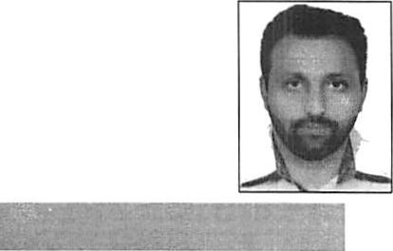

Seeking a good carrier and holding a responsible position in the organization and to ensure credible performance to work hard towards exceeding the set goals and contribute for the

organization growth.

*Personal Info*

Date of Birth Marital Status Nationality Religion Language Visa Status Driving License Driving License

April 05 1978

Married

Pakistani

Islam

English, Arabic, Urdu  
Employment Visa

Valid Dubai UAE light Vehicle Driving License  
VALID UK DRIVING LICENSE

*Work Experience*

O Currently working as Light Vehicle Driver in Road & Transport Authority, Dubai UAE from March 2017 to till date.

3 Siraj Marine Services (Ajman, UAE)

Food Partner (London, England)

3 Post: Public Relationship Officer

Organization: Siraj Marine Services, Ajman Tenure: Oct, 2015 - March, 2017

My jobresponsibilities included:

* To handle port authorities to clear Ship.
* Custom clearance

•> In ward & out ward clearance.

* NTA
* Developing Good relationship with custom authorities to handle the critical issues smoothly.
* To extend support for Crew Immigration Clearance.
* To work closely with Immigration & labour office issues to handle assigned tasks.
* To coordinate with management &other team members to handle legal issues.
* To prepare daily report of my visit and submit it to the operational manager.
* To keep an eye on Du offers and to mention them in my daily report.
* To maintain good professional relationship with customers.
* Flexibility in working hours.

Z> Post: Quality Control Officer

Organization: Food Partner

Tenure: February 2010 - January 2013

1. was responsible for all overall Quality related activities for Food Partner. My job also includes

To check that Food sold to customers is Hygienic.

* Meeting health standards.
* Responsible for customer satisfaction about food quality.
* To ensure staff is meeting health authorities criteria.
* To generate customer loyalty and customer retention.
* To prepare QC report on weekly basis.
* Greeting drop-ins and respond to inquiries.



* Bachelor in Arts

Sargodha University, Pakistan. (2000-2002)

* Foundation in Arts

Sargodha Board, Pakistan. (1998-2000)

*Other Skills*

* Ability to multi-task and prioritize effectively

•> Flexibility in work hours and also Good communication (oral-written)

* Aggressive & Result oriented.
* Ability to grasp concepts and logic quickly with focus on implementation.
* Capable of handling challenging and difficult situations.



Outdoor Games

Excellent in Basketball, Cricket, Football Indoor Games

Compare and Debater, Different games of Cards, Badminton, a very good stage actor, Singer, etc.