Abdulla  Email : Abdulla.281059@2freemail.com | 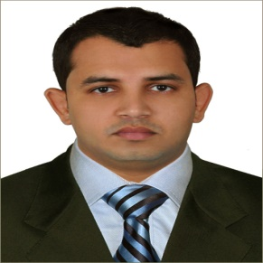

Carrier Objective:
To work with an esteemed organization where I can perform assigned tasks timely, accurately & effectively with all my skills & abilities that I acquired from my previous experiences as per the company’s policies for mutual benefits.

Strengths:
- Self motivated, Obedient, Sincere and Punctual
- Ability to work in group as well as independently under any pressure.
- Systematic, Ability to learn faster.

Overview:
More than 6 years combined experience in customer services. Have 5star hotels experience, personal assistant and Transport supervisor experiences. Seeking an opportunity with your well-established Organization.

Employment History
1. Designation : Personal Assistant.
Organization : Lindenberg Emirates Llc, Abu Dhabi, Uae
Duration : From Sep 2014 To Still

2. Designation : Customer service agent
Organization : Atlantis The Palm Dubai,Uae
Duration : From Dec 2012 To Sep 2014.

3. Designation : Executive Shauffeur
Organization : Personal Driver,Dubai, U.A.E
Duration : From March 2012 Till To October 2012 .

4. Designation : Executive Shauffeur And Team Leader
Organization : Yas Viceroy Hotel, Abu Dhabi, U.A.E
Duration : From Jul 2009 Till To 08/04/2012

5. Designation : Sales Executive
Organization : Edappal Electricals , Kerala , India
Duration : From July 2005 - August 2008

Academic Qualifications:
- Bachelor Of Business Administration (BBA), Kinsale University USA
- Higher Secondary School (Board of Higher Secondary Education, Kerala)
- SSLC (Secondary School Leaving Certificate)

Technical Qualifications:
- Computer Expertise ( Basic Awareness in MS Office Packages )

Personal Summary:
- Date of Birth : May 23/05/1985
- Nationality : Indian
- Gender : Male
- Marital Status : Married
- Validity : 15 April, 2022

Languages Known : English, Malayalam, Arabic and Hindi
- Visa Status : Employment. 28/10/2016.
- U. A. E Driving License Type :: Light Vehicles

I here by declare that the above-mentioned information is correct up to my knowledge and I bear the responsibility for the correctness of the above-mentioned particulars.

Yours sincerely,

Abdulla

