OBJECTIVE
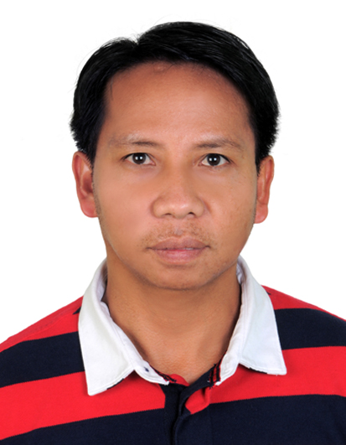
To join a professional organization wherein I can share and make use of the vast knowledge, skills and experiences that I gained from my previous employment.

PROFESSIONAL QUALIFICATION

Professional : COMPUTER SCIENCE
School : MCN Computer College, Philippines
Date of Completion : December 1992
Government Licensure : Civil Service Eligibility
Professional License
DATA ENCODER (NCI) TESDA with Certificate of Competency

POSITION DESIRED:
- Storekeeper/Assistant Storekeeper
- Logistics Coordinator
- Technical Clerk

CAREER SUMMARY:
My experience of 25 years working in Government and Private organization as Data Encoder, Accounting Clerk, Secretary and Logistics, makes me capable and able person to handle all types of field in Computer operations, Secretarial, Administration, Accounting & Logistics.

During my academic/professional career, I have invariably interacted with various personalities of high academic caliber and successfully executed several independent assignments as a part of my course/job. This has given me confidence and strength to face any challenging situation with competence and diligence. With this confidence and capability, I presume to work for a reputed and professional organization like yours, for the post applied for.

WORK EXPERIENCE:
Logistics Coordinator/Sales Clerk
Union Gulf Services LLC.
Abu Dhabi, United Arab Emirates
February 2004 to Present

Duties & Responsibilities
- Clearing Air Shipment & Sea Shipment.
- Preparing Duty Exemption Letter for Shipment Clearances.
- Receiving material: Receive the material from the supplier. At the time of receipt of material, Checking and identifying the materials according to the Part Number as per Purchase Order required & specification.
- Arranging materials: The materials received will arrange in a proper manner. Bins will be allotted to each and every item.
- Recording: as a duty of the store keeper I will record the receipt and issue of material in the respective bin card regularly. It will indicate the quantity of stock held by the store every time. For recording, and maintains store ledger and bin cards.
- Issue of material: In-charge of issuing the material as per the requisition of the production.
- Preparing/Typing Delivery Order.
- Arranging Pick-up and Forklift for Loading and Offloading of Materials.
- Preparing Labels, Tags and Stickers for Materials ready for delivery.
- Delivering Materials to Government like: (ADNOC, NDC-National Drilling Co, ZADCO, ADGAS, ADMA-OPCO, TAKREER, GASCO, ADCO, IRSHAD and other government and Private Companies).
- Preparing Invoices after Deliveries.
- In charge on Storekeeping.
- In charge on issuing of Materials.
- In charge on Inventory of stocks.
- Encoding Data, Typing/Preparing Quotations, Making Quotations, Follow-up status of Materials to the Agents, Follow-up Payments & Collecting payments to Vendors.
- Maintaining the Status/Controls of Purchase Orders according to the Due Dates of delivery to vendors to avoid overdue and demurrage charges thru ACCESS PROGRAMING & EXCEL.
- Controlling Records using the Access Programming like: INVOICES-ready to give updates for Accounts needs, PURCHASE ORDERS - ready to give updates to the Sales Department for their Dues of Material Delivery on or before the delivery date.
- Maintaining Controls for the status of PURCHASE ORDERS either Complete or Partial Delivery done and for the INVOICES weather the status is CLOSED.

Data Entry Operator/Billing Clerk
National Irrigation Administration
Dummun River Irrigation System - Philippines
December 1998 to February 2004

Duties & Responsibilities
- Encode various information requirements and reports needed by the different departments like contemporary letters to clients, engineering requirements, Program of Works, material cost estimates, billings, material status of various projects, purchase reports, material variance reports and etc.
- Preparing Bills & Statement of Accounts.
- Responsible for the repairs and maintenance of hardware/softwares. Propose options for repairs incase could no longer fix the defect.
- Keeping Incoming and Outgoing memo and taking radio messages.
- Performing other encoding jobs as requested.

Accounting Clerk/Secretary
Daytime Multi-Purpose Cooperative Inc.
Philippines
January 1993 to December 1998

Duties & Responsibilities
- Encoding Data, Recording/Bookkeeping, Taking minutes of the BOD meeting, Preparing Statement of Accounts of members/borrowers. Distributing Net Surplus to members.
- Assisting the Bookkeeper in preparing Financial Statement,
- Corporate Collector

Data Entry Operator
Local Government Unit – (Municipal Hall)
January 1992 to December 1992
Philippines

Duties & Responsibilities
- Encoding Data/Reports, Filing, Binding.
- Performing other encoding jobs as requested.
PERSONAL APPRAISAL
Sincere and Honest
Hard Working
Quick Learner

I.T AND COMPUTER EXPERTISE:
- Microsoft Office: Having good knowledge & experience on Microsoft Word, Microsoft Excel, Microsoft Access, and Power Point & Microsoft Outlook.
- Keeping knowledge & experience on Hardware Utility, Internet, PC Assembly, PC Networking, Adobe Photo Shop, Repairing Document/Editing.

PROFESSIONAL SKILLS AND TRAININGS

Accounting For None-Accountant
Filipino Digerati Association Phil. Embassy, Dubai, U.A.E

Access Programming – Outstanding Graduate Award
Filipino Digerati Association Phil. Embassy, Dubai, U.A.E
MS Excel Superior
Filipino Digerati Association Phil. Embassy, Dubai, U.A.E

PC Assembly Course
Philippine Embassy, Abu Dhabi, U.A.E

Personal Computer Networking Course
Philippine Embassy, Abu Dhabi, U.A.E

Graphics Design Course
Philippine Embassy, Abu Dhabi, U.A.E

Cooperative Book keeping & Accounting
Land Bank of the Philippines and Cooperative Development Authority

WINDOWS/MSWORD/EXCEL/POWER POINT
MCN Computer College (Philippines)

ISF Computerized Billing
National Irrigation Administration (Philippines)

Electronic File Exchange Program
Government Service Insurance system (Philippines)

