Khushi
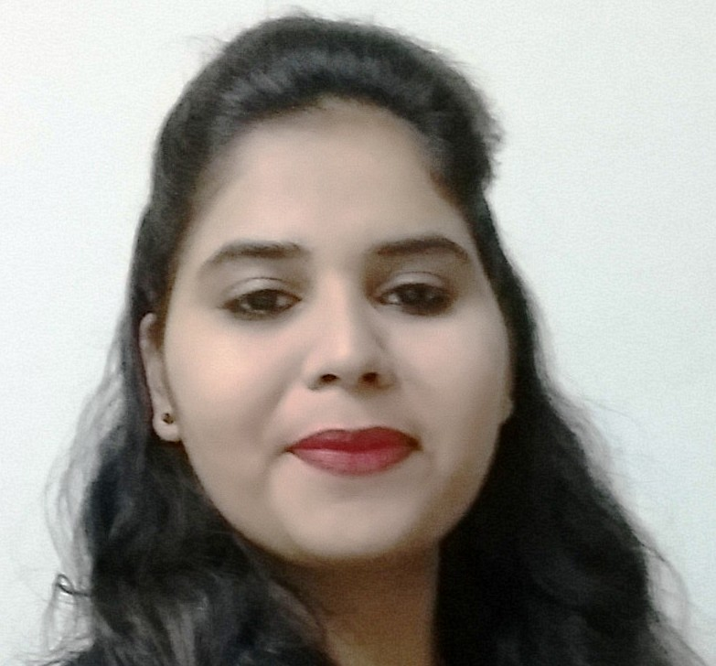
Email: khushi.281391@2freemail.com
Visa Status: Husband Visa

OBJECTIVE
To get associated with a progressive organization, through which I can gain valuable practical experience and sharpen my skills by working in challenging environment.

WORKING EXPERIENCE
ORGANIZATION : Tex Mart Ajman (Oct 2015 to Feb 2016)
DESIGNATION : Receptionist (Part Time)
- Answering Incoming calls.
- Mail Distribution.
- Handling Company Inquiries.
- Arranging couriers.
- Keeping the reception area tidy.
- Making Invoices and DO.
- Handling Petty Cash.

ORGANIZATION : ENBEE GENERAL TRADING (Feb 2015 to Aug 2015)
DESIGNATION : Receptionist cum Secretary
- Making Invoices.
- Meeting and greeting clients.
- Booking meetings.
- Arranging couriers.
- Keeping the reception area tidy.
- Answering and forwarding phone calls.
- Handling Petty Cash.

ACADEMIC QUALIFICATIONS
PG | MCA | Lucky Institute of Professional Studies , RTU | 76.37% | 2014
UG | BCA | Mahila PG Mahavidyalaya , JNVU | 68.08% | 2011
CLASS XII | Commerce | Balika Adarsh Vidya Mandir, Jodhpur , RBSE | 60.62% | 2008
CLASS X |  | Balika Adarsh Vidya Mandir , Jodhpur, RBSE | 61.83% | 2006

ACCOMPLISHMENTS
PROPERTY DEALING 2014
- Developed a web based application for the management of Apartments , Row House and Land for
property dealing system using C#.Net with the help of templates
- Only Registered Person can contact in this Site

CAMPUS SELECTION SYSTEM 2013
- Developed a web based application to check authencity of colleges and students for campus recruitment using C#.Net
- Only genuine cases forwarded by the application to the admin after several check ups

BOOK STORE MANAGEMENT 2011
- Developed a desktop application for the management of a book store using VB
- Availability of books , stock left , timely reorder , addition of a new book ,deletion of an old record etc. could be easily performed

TECHNICAL AREA
- Languages Known : VB , Asp.Net, C#.Net , C , Cpp
- Databases : Oracle , SQL
- O.S : MS DOS , Windows ,
- Web Development : HTML , Asp.Net
- Core Concept : DBMS, DS, DMS.
- Tools : EDraw Max, MS-Office, Internet, Tally

TRAINING
- Achieved Four Month Training in Asp.Net from Surat
- Achieved 93% in MCA Last Semester and also got First Rank in college

I

EXTRA CURRICULAR ACTIVITIES
- Won a technical test and a second ranker in web site designing in intra college competitions
- Presented various topics like Search Engine Optimisation , USB as a RAM etc. at the seminars
- Participated in Seminars presented on languages like LINUX and others like HACKING etc.
- Participated in intra college debate on Union Budget
- Participated in various essay writing competitions on sensitive issues like “foeticide”
J

ADDITIONAL INFORMATION
- Fluent in English , Hindi and Sindhi
- Hobbies include computer programming ,keeping a watch on latest technology, watching movies

BEHAVIORAL CHARACTERISTICS
- Tech-savvy
- Committed to Quality and Result oriented
- Quick learner and Sincere in Attitude
- Can Adjust to any Situation
- Friendly but Disciplined
- Confident and Focused

PERSONAL DETAILS
Date of Birth : 24th/July/1990
Language Known : Hindi, English, Sindhi.
Marital Status : Married
Nationality : Indian

