Curriculum Vitae
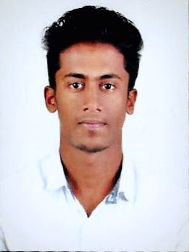 | NIHAL  Automation in PLC, Electronics & Communication Engineer  Email: nihal.281633@2freemail.com

OBJECTIVE
To be associated with a progressive and prestigious organization that provides an opportunity to apply my knowledge and skills in order to keep abreast with Latest trends and technologies and thus serving my organization, society and the nation by hard work and dedication.

EDUCATION AND SPECIALIZED TRAINING
2015 - 2016  2011 - 2015  Percentage: 55%  2009 - 2011  Percentage: 76%  2008 - 2009  Percentage: 66% | PLC - IPCS-AUTOMATION  PLC MITSUBISHI - Calicut, Kerala, India.  B. TECH in Electronics and Communication Engineering  KMCT College of Engineering, Calicut University - Calicut, Kerala, India.  Higher Secondary  JDT ISLAM Higher Secondary School- Calicut, Kerala, India.  SSLC- CBSE  MARKAZ English Medium School - Calicut, Kerala, India.

SOFTWARE SKILLS
Application Software  Other | PLC-SCADA MITSUBISHI,  MPLAB IDE, Proteus (PCB Layout), DSP, VLSI, MATLAB.  Microsoft Office, C Programming, Adobe Photoshop

INDUSTRIAL EXPERIENCE
1. Training at AUTOMATION PLC-SCADA  2. 10 Days internship on Embedded Systems  3. Manufacture Industry  4. Virtual Blue Printing Robot Manufacture. | MITSUBISHI [IPCS]  KELTRON  KELTRON  FOCUS INFOTECH

PROJECTS
1. Virtual Blue Printing Robot
2.Automatic Room Light Controller

SEMINAR
1. MEMS based switches for high power applications (IEEE Standards)

COMPETENCIES
- Good leadership quality.
- Excellent in Team work.
- High grade Responsibility.
- Positive attitude.
- Event management ability.
- Excellent written, communication, inter personal and problem solving skills.
- Willingness to take responsibility.
- Fast learner.
- Good analytical skills.
- Effective managerial skills.
- Ability to work in multi cultural environment.

EXTRACURRICULAR ACTIVITIES AND ACHIEVEMENTS
- Actively participated various cultural as well as athletic activities for inter school fest.
- Active member of “TEDEX” electronics and communication engineering student association “KMCT College of engineering”.
- Procurement committee HEAD and Assistant finance controller for Techno Managerial Extravaganza KARMA’15 conducted by KMCTCE, Calicut.
- Successfully Volunteered National Service Scheme [NSS].

LANGUAGES
ENGLISH, HINDI, MALAYALAM, TAMIL

DECLARATION
I hereby declare that the above-furnished information is true to the best of my knowledge and I alone shall be responsible for any flaws herein.

